UNIVERSITY OF LJUBLJANA
SCHOOL OF ECONOMICS AND BUSINESS

ASSESSING THE ACCURACY AND PROFITABILITY OF USING MACHINE LEARNING MODELS FOR PREDICTING BETTING ODDS ON THE CASE OF SLOVENIAN FIRST FOOTBALL LEAGUE

Ljubljana, September 2025 | MARIO VEŽIĆ

AUTHORSHIP STATEMENT
The undersigned Mario Vežić, a student at the University of Ljubljana, School of Economics and Business, (hereafter: UL SEB, author of this written final work of studies with the title ”Assessing the accuracy and profitability of using machine learning models for predicting betting odds on the case of Slovenian first football league”, prepared under supervision of prof. dr. Luka Tomat.
DECLARE
- this written final work of studies to be based on the results of my own research;
- the printed form of this written final work of studies to be identical to its electronic form;
- the text of this written final work of studies to be language-edited and technically in adherence with the UL SEB’s Technical Guidelines for Written Works, which means that I cited and / or quoted works and opinions of other authors in this written final work of studies in accordance with the UL SEB’s Technical Guidelines for Written Works;
- to be aware of the fact that plagiarism (in written or graphical form) is a criminal offence and can be prosecuted in accordance with the Criminal Code of the Republic of Slovenia;
- to be aware of the consequences a proven plagiarism charge based on the this written final work could have for my status at the UL SEB in accordance with the relevant UL SEB Rules;
- to have obtained all the necessary permits to use the data and works of other authors which are (in written or graphical form) referred to in this written final work of studies and to have clearly marked them;
- to have acted in accordance with ethical principles during the preparation of this written final work of studies and to have, where necessary, obtained permission of the Ethics Committee;
- my consent to use the electronic form of this written final work of studies for the detection of content similarity with other written works, using similarity detection software that is connected with the UL SEB Study Information System;
- to transfer to the University of Ljubljana free of charge, non-exclusively, geographically and time-wise unlimited the right of saving this written final work of studies in the electronic form, the right of its reproduction, as well as the right of making this written final work of studies available to the public on the World Wide Web via the Repository of the University of Ljubljana;
- my consent to publication of my personal data that are included in this written final work of studies and in this declaration, when this written final work of studies is published.
- that I have verified the authenticity of the information derived from the records using artificial intelligence tools.
Ljubljana, ____08.07.2025.____________ Author’s signature: ____Mario Vežić__________________
(Month in words / Day / Year,
e. g. June 1st, 2012

TABLE OF CONTENTS
1 INTRODUCTION 1
2 ARTIFICIAL INTELLIGENCE 4
2.1 Overview of Artificial Intelligence Core Concepts and Applications 4
2.2 Definition and Types of Machine Learning 8
2.3 Methodologies for Machine Learning Development 10
3 USE OF ARTIFICIAL INTELLIGENCE IN THE FOOTBALL BETTING INDUSTRY 12
3.1 Overview of the Domain of Football Betting and Odds Compilation 13
3.2 Role of Artificial Intelligence in Football Betting 14
3.3 Overview of Machine Learning Algorithms 18
3.3.1. Discriminative Models – Probabilistic and Geometric 19
3.3.1.1. Logistic Regression 19
3.3.1.2. Support Vector Machine 20
3.3.2. Ensemble methods 25
3.3.2.1. Gradient Boosted Trees 27
3.3.2.2. eXtreme Gradient Boosting (XGBoost) 28
3.4 Relevance and Usefulness of the Nested Cross-Validation Procedure 29
4 DEVELOPMENT OF THE ML MODEL FOR THE FOOTBALL MATCHES’ OUTCOME PREDICTIONS 32
4.1 Collection and Compilation of Historical Match Data and Model Features 33
4.2 Preprocessing Steps (e.g., Cleaning, Feature Selection, Scaling) 35
4.3 ML Model Development and Hyperparameter Tuning 38
4.4 Model Evaluation Metrics and Performance Assessment 41
4.5 Comparative Analysis of the Model Performance Across Algorithms 42
5 RESULTS 44
5.1 Generating the Betting Odds 45
5.2 Evaluation of the Odds’ Accuracy and Profitability 48
6 DISCUSSION 51
6.1 Presentation of the Main Findings 51
6.2 Limitations of the Study 53
6.3 Suggestions for Future Research and Improvements 55
6.4 Consideration of Ethical and Regulatory Issues in Sports Betting 56
7 CONCLUSION 57
REFERENCE LIST 59
APPENDICES 1
LIST OF TABLES
Table 1: Nested cross-validation for the betting outcome 1 41
Table 2: Nested cross-validation for the betting outcome X 42
Table 3: Nested cross-validation for the betting outcome 2 42
Table 4: Accuracies of cross-validated logistic regressions on training datasets 45
Table 5: Accuracies of cross-validated logistic regressions on test datasets 45
Table 6: Confusion Matrix for the outcome 1 46
Table 7: Confusion Matrix for the outcome X 46
Table 8: Confusion Matrix for the outcome 2 46
Table 9: Accuracies of the odds for the outcome 1 48
Table 10: Accuracies of the odds for the outcome X 48
Table 11: Accuracies of the odds for the outcome 2 48
Table 12: Comparison of the confusion matrices for the outcome 1 49
Table 13: Comparison of the confusion matrices for the outcome X 49
Table 14: Comparison of the confusion matrices for the outcome 2 49
Table 15: Profitability analysis for the outcome 1 50
Table 16: Profitability analysis for the outcome X 50
Table 17: Profitability analysis for the outcome 2 50
LIST OF FIGURES
Figure 1: Four industrial revolutions 5
Figure 2: Levels of AI proficiency 6
Figure 3: Basic schema of neural networks in deep learning 7
Figure 4: SARSA model of reinforcement learning 10
Figure 5: Phases of ML development methodology 11
Figure 6: Accuracies of AI algorithms used for betting across sports 15
Figure 7: Accuracy of AI algorithms for the predicting purposes across various sports 16
Figure 8: Ranked Probability Scores for betting organizations and AI algorithms 17
Figure 9: Achieved profits by fixtures using AI algorithms for football betting 17
Figure 10: Plotting the data and determining convex hulls in SVM 21
Figure 11: Calculating the optimal hyperplane as a boundary line in SVM 22
Figure 12: Soft Margin SVM for non-linearly separable data 23
Figure 13: Linearly vs Non-linearly separable data in a two-dimensional space 24
Figure 14: Using Gaussian RBF kernel function for the non-linearly separable data 25
Figure 15: Example of a voting method in the bagging ensemble learning 26
Figure 16: Boosting approach of the ensemble learning methods 27
Figure 17: Gradient descent algorithm for iterative optimization 28
Figure 18: An illustration of k-fold cross-validation with 5 folds 31
Figure 19: Nested cross-validation with 4 outer CV folds and 2 inner CV folds 32
Figure 20: Correlation matrix for the initial 62 features 36
Figure 21: Correlation Matrix for the final set of 24 features 38
Figure 22: Example of the bookie's betting list with odds compiled for the week 1 of the season 2023/24 47
Figure 23: Example of the bookie's list with the betting odds from 1XBet for the same events (for comparison) 47
Figure 24: Example of the bookie's list with the betting odds from William Hill for the same events (for comparison) 47
LIST OF APPENDICES
Appendix 1: Summary in Slovenian 1
Appendix 2a: List of features (overall season success) 2
Appendix 2b: List of features (club's general and financial characteristics) 3
LIST OF ABBREViATIONS
AI - Artificial Intelligence
ML - Machine Learning
nCV - Nested Cross-Validation
ANI - Artificial Narrow Intelligence
AGI - Artificial General Intelligence
ASI - Artificial Super Intelligence
ANN - Artificial Neural Network
NLP - Natural Language Processing
SARSA - State-Action-Reward-State-Action
AD - Anno Domini
US - United States
GDP - Gross Domestic Product
EU - European Union
UK - United Kingdom
SVM - Support Vector Machine
RPS - Ranked Probability Scores
EPL - English Premier League
GBT - Gradient Boosted Trees
XGB - eXtreme Gradient Boosting
CV - Cross-Validation
VIF - Variance Inflation Factor
LASSO - Least Absolute Shrinkage and Selection Factor
RBF - Radial Basis Function
ROC AUC - Receiver Operating Characteristic Area Under the Curve
TP - True Positives
TN - True Negative
PP - Predicted Positives
PN - Predicted Negatives
ROI - Return On Investment

INTRODUCTION
The industry of football (or “soccer”, depending on the regional terminology) has long been proven to have transcended its leisurely origins of yet another sporting activity or entertainment form for the masses. As a matter of fact, its transformation into a serious business opportunity became quite apparent in the late ‘90s, when multiple football clubs floated on a stock market and started presenting themselves as more akin to the other for-profit corporations (Kelly et al., 2012). These ventures into selling the shares on the market had brought a lot of success, and only a couple years later a new era of investing was introduced to the world of football. It all began with the case of the Fulham F.C. in 1998 (Rohde & Breuer, 2016), with the foreign (primarily Arabian) private investors buying out the positions of the club’s majority shareholders. The purchase in question was acquired for a staggering amount of 30 million pounds at the time (about £67,463,891.72 today), and yet the amount of money to be involved in the football industry would quickly take an exponential raise even further. In fact, only 20 years later, the Chelsea F.C. club ended up owing a staggering 1.6 billion pounds to the former owner, a Russian oligarch and politician Roman Abramovich, due to his overall investments in the club (Bason & Senaux, 2023).
With the focus within the industry shifting more towards financial opportunities, the ground has been laid for the upcoming dominance of the betting market. To that extent, the Fulham F.C. once again became a trailblazer, being the first football club to be officially sponsored by a betting company (“Betfair”) for their 2002/03 season (Sharman, 2020). This practice of sponsorships from betting companies has flourished ever since, with even the entire national leagues taking on betting companies as their official sponsors – as is the case of the current Serbian Super League, being sponsored by the “Mozzart Bet” company, one example out of many. And as betting has established its ubiquitous presence in the industry, it managed to achieve quite fascinating financial performances on the market, accounting for 83.65 billion dollars globally (with the forecasted compound annual growth rate of 10.4% reaching 182.12 billion dollars for the year 2030) – out of which, football has registered the largest share among other sports with over 24.0% (Grand View Research, 2023). With such a substantial revenue, it was to be expected that the betting industry would witness significant transformations within itself as well, evolving alongside the technological innovations and incorporating them in various manners; be it in the forms of the new mediums for interactions such as online betting (Lopez-Gonzalez & Tulloch, 2015), or the new means for payments such as cryptocurrencies (Topps, 2023).
To that extent, one of the biggest and most significant evolutions present in the betting industry (and ongoing still) concerns the very manner in which its foundation is being created – the compiling of betting odds. As it was in the past, the process of odds compiling, or setting likelihoods for the upcoming events (Grimes & Schulz, 2008) for clients to bet on, was for the longest time based primarily on the expert analyses of available historical data by the bookmakers, in order to achieve as accurate predictions as possible while also ensuring the profits for their betting provider (Štrumbelj, 2014). In other words, for the first half of the past century, the process of compiling odds was based more on the individual assumptions and expertise rather than actual data analysis. This, understandably, wasn’t proving to be highly accurate, and thus in the second half of the century more complex mathematical models were employed instead. To name a few examples, there were applications of least squares approaches to betting (Stefani, 1980) and even the utilization of Fibonacci sequence (Archontakis & Osborne, 2007), attempting to process large quantities of data and provide meaningful results. However, the sheer amount of information needed to be processed, as well as the inevitability of human errors happening in the following analysis of the data, necessitated the introduction of something like machine learning to the world of football betting (Horvat & Job, 2020).
Machine learning (ML) is a term used for algorithms that function similarly to the human’s experiential learning: by taking in large datasets, recognizing the potential patterns, and providing predictions or recommendations – all beyond human capabilities (Helm et al, 2020). Taking that description into an account, alongside the previous issues that plagued the field, it was fairly obvious that ML could be an ideal approach for the sports betting industry. However, while the introduction of machine learning models solved a number of problems in the field, it also brought along some new challenges to be solved, such as: the choice of the optimal ML algorithm for the task, model’s feature selection, training and validation of data, as well as the optimization of ML parameters and hyperparameters (Horvat & Job, 2020).
The purpose of this master’s thesis is to provide empirical evidence for feasibility and effectiveness of utilizing advanced computational techniques (in the form of machine learning algorithms) on the case of compiling odds for the Slovenian football league, and thus offer relevant stakeholders valuable insights into the tackled area.
Various attempts at modeling likelihoods via ML already exist for more prominent leagues, such as English (Baboota & Kaur, 2019), Spanish (Bai et al., 2023) and German (Kozak & Głowania, 2021) competitions. However, there is still no published attempt at tackling the task for the format with: fewer clubs and smaller budgets on one hand, and more parity and unpredictability on the other – especially in comparison to the “Big 5” (the term used for the group of English, Spanish, Italian, German and French leagues due to their individual market sizes being greater than all the other European leagues’ combined (Statista Research Department, 2024)).
Besides the focus on the Slovenian national league with its unique aspects, this research also attempts to approach the issue at hand on a more methodologically sound way in comparison to the existing corpus of research. This improvement in methodology is in regards to the ML algorithms selection and hyperparameter tuning, by opting for the underutilized nested cross-validation (nCV). The nCV technique uses a pair of nested loops in which the model selection process is optimized in the so-called “outer loop” while the hyperparameters for the model training are optimized in the “inner loop” (Cawley & Talbot, 2010). Thus, using the nCV should lead to the mitigation of the possible overfitting issue, while also leveling the various algorithms among each other, ensuring more trustworthy generalizations of the model’s estimates on the unseen data (Yates et al, 2023).
To that end, the goals of my master thesis are as follows:
- to design and implement an ML-based model for predicting the outcomes of football matches in the Slovenian first league by utilizing the nested cross-validation;
- to calculate the betting odds for the Slovenian first league’s matches;
- to evaluate the predictive performance of calculated betting odds for the Slovenian first league’s matches and compare it to the competitors’ odds on the market;
- to evaluate the profitability of calculated betting odds for the Slovenian first league’s matches in comparison to the odds provided by competitors on the market.

For the theoretical part of the master thesis, the focus is placed on the extensive research of contributing factors in the world of football that may influence the outcomes of the matches yet to be played. A literature review serves as the basis for creating the list of features used in the ML models, and personal expertise in regards to the topic supplements and enriches the catalogue of variables.
The empirical part that follows emphasizes the machine learning utilization. Before the models themselves were put into action, the feature selection had taken place, based on the multicollinearity detection and its mitigation. Afterwards, the model selection was conducted in the form of nested cross-validation, encapsulating different algorithms (Logistic Regression, Support Vector Machine, Gradient Boosted Trees, XGBoost). Once the optimal model was created, the odds were calculated based on the predicted probabilities, and the accuracy and profitability of these generated odds was assessed in comparison to the rival odds existing on the market.
The structure of the thesis is as follows: following the current first chapter “Introduction” that provides insight into the purpose of the thesis overall, the second chapter “Artificial Intelligence” describes the history of AI in the context of being used for business purposes, defines it and its types, and describes the various ways in which it can be applied. The chapter also focuses on the particular branch of AI, the machine learning, covering its types as well as the standardized approach to ML project development. The third chapter “Use Of Artificial Intelligence In The Football Betting Industry” starts with a brief overview of the domain of sports betting, with a focus on football betting in Europe, and provides a literature review of AI being used for these purposes. It also offers an in-depth explanation of all of the ML algorithms that are utilized in this thesis, as well as the explanation for the nested cross-validation as a procedure that ought to elevate the methodological soundness of the research at hand. Afterwards, the analyses of the thesis begin in the fourth chapter titled “Development Of The ML Model For The Football Matches’ Outcome Predictions”, as the chapter prepares the setting with the description of the context for the analyses (Slovenian First League), the collection of data being used (alongside a literature review for the features’ relevance), and the preparation of data in the form of cleaning, scaling, feature engineering and feature selection. The preparation and the results of the nested cross-validation containing 4 ML algorithms then follows, with the algorithms’ performances compared via various evaluation metrics. In the fifth chapter “Results”, the optimal algorithm from the nCV had undergone an additional analysis for the three main outcomes of a football match, resulting in models whose performances are also evaluated. The models served as a basis for generating the betting odds, and those odds were compared to the odds available by 1XBet and William Hill betting companies, which were chosen due to the companies’ relevance in the field. The comparison was done in the context of the odds’ accuracy and profitability. These results are then interpreted in the context of the thesis’ goals in the sixth chapter “Discussion”, which also provides a list of the limitations present in this research and the suggestions to overcome those limitations. The chapter ends with a reminder of the dangers of gambling and betting activities, the forms in which those can manifest in an individual, and helping tools are offered in the form of advices to recognize and prevent its consequences. The final chapter “Conclusion” summarizes the main goal of the thesis, the success of the conducted research and the development of the research field.

ARTIFICIAL INTELLIGENCE
Following the introduction to the thesis, this chapter explores the vast field of AI – its emergence as the new driving force in the world of business as a new industrial revolution, a number of definitions and (sub)types to better understand it, as well as its most prominent applications. The chapter continues further with the defining and describing of the field of machine learning, a branch of AI that is at the very center of the thesis. The classification of main ML types is explained, followed by the step-by-step description of methodology for successful ML development.

Overview of Artificial Intelligence Core Concepts and Applications
Each new era that society enters brings along a new set of trends, technologies and resources to organize itself around. Accordingly, the second half of the 20th century has provided a glimpse into what the ensuing change will lean towards, with the transition to the so-called “post-industrial society” – a period from the 1960s till the late 1980s which: introduced first steps of automatization of the manual labor via development of the “mainframe” and micro- computers (Simos et al., 2022), highlighted the importance of a healthy and sustainable work-life balance for the workers (Balatsky, 2021), and slowly started centering the industry around production, distribution, storing and supplying information as an intangible form of resource for a change (Oettinger, 1980). In the words of an American sociologist Daniel Bell, this era was succinctly described in a way that “what counts is not raw muscle power, or energy, but information” (Bell, 1976). However, with the rapid advancement of the technology during this period, more and more mediums for distributing large quantities of information became widely available, constantly affecting people’s everyday lives – both professional and personal. This, in turn, in the 1990s led to the so-called “information abundance”, an occurrence when there is too much relevant information that it reaches the point where it stops being helpful and instead becomes a hindrance (Bawden & Robinson, 2020). The ever-accumulating influx of information became unbearable for many at the time, and a study has been conducted indicating that the resulting stress of this new way of life began to negatively affect people’s health, since they could no longer manage all this information effectively (Waddington, 1997).
This newly emerged issue necessitated some sort of solution. Besides the altruistic efforts to help individuals better their health, the aim was to additionally find more efficient ways to process and utilize all of the information that was becoming available at unprecedented rates, and thus maximize the possible profits from it. This has led to the emergence of what’s now described as the “fourth industrial revolution”. Building upon the already existing progress in computer technology (in the terms of hardware, software and networks alike), this revolution further improved the speed and breadth of which these technologies impact the everyday lives, becoming even more widespread while simultaneously simplifying the process of handling huge amounts of information to the end-users (Schwab, 2017). And while the third industrial revolution focused on the automatization of solely manual labor, the fourth revolution went one step further and aimed at replicating the intellectual labor, or in other words, the human cognitive process via machines (Figure 1), in the form of this era’s landmark technology called “artificial intelligence” (AI) (Chatterjee, 2020).

Figure 1: Four industrial revolutions
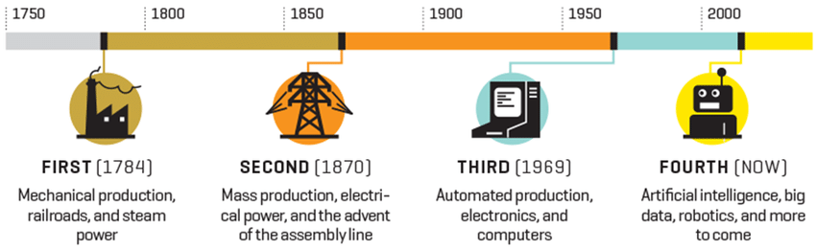
Source: Demandbase (2017).

To conclusively define “AI” is still somewhat of an elusive endeavor – however, there are certain aspects that most of the academia seems to agree on. For starters, the AI is considered as an area of study that is primarily in the field of computer science, and as such is concerned with creating systems that can think/act like humans, or think/act rationally in general (Kok et al., 2009). However, here is where a distinction can be drawn already: between the approaches that, on one hand consider a successful AI as one that is able to merely simulate the process of human decision-making, and on the other hand the one that demands of a system to be able to actually think on its own and not just mimic it through optimization calculations. The first approach is also called as the “weak AI”, as it performs various actions by “making” decisions, however these decisions are simply the result of calculating the probabilities of outcomes for possible actions and choosing the one with the best outcome – in other words, solving a mathematical equation. The second approach, the “strong AI”, expects of the system to think about the problem at hand by learning from its own experience, not just by crunching the numbers provided to it. Thus, by adding the experiential angle it should be much more akin to the actual process of decision-making as performed by a human being (Martinez, 2019).
While this attempt at the “strong AI” certainly sounds quite ambitious, in reality AI can be categorized into three levels of proficiency, and accordingly it can be concluded that even today, over 30 years since the beginning of the fourth revolution, only the first level out of those has been substantially advanced upon (Figure 2). The levels at hand are, as follows: Artificial Narrow Intelligence (ANI) – the application of AI in one particular task it should excel at, and at nothing else; Artificial General Intelligence (AGI) – the broadest understanding of AI, where it reaches the ability to completely mimic the human intelligence in every aspect and is thus able to learn from its experience; Artificial Super Intelligence (ASI) – an ideal of AI surpassing the human intelligence and deeming it inferior in every way imaginable (Strelkova, 2017). With this categorization in mind, it should still be noted that even the second level of AGI seems to be unreachable for the current state of available technology. Thus, mentioning of the AI onwards will primarily focus on the scope of the ANI level – or in other words, the ability to apply AI concepts on specific tasks in which it can outperform humans due to the ability to store and process incomparably larger amounts of information in incomparably shorter amount of time.

Figure 2: Levels of AI proficiency

Source: Vishakan (2024).
The increasing development of the AI field has naturally led to the expansion of the terms related to it, covering different areas and its various possible applications. The key concepts relevant for the understanding of AI include: deep learning, natural language processing, computer vision, robotics and machine learning. Following are the brief descriptions of these concepts:
- Perhaps the technique that most resembles what artificial intelligence strives towards in general, deep learning is a field that utilizes artificial neural networks (in short “ANN”) for the purpose of simulating the way the actual human brain processes information and conducts decision making (Chatterjee, 2020). The mentioned ANNs represent interconnected networks of building blocks called nodes (akin to neurons in brains), that are able to process information in a non-linear parallel manner (Figure 3). In order to process data with higher level of complexity successfully, these networks of nodes are more often multi-layered and hierarchical (Deng & Yu, 2014), and the connections between the nodes that mimic brain’s synapses are called synaptic weights – values that indicate the strength of impact the stimuli have on the network, and its ability to successfully recognize them (Zahner & Micheli-Tzanakou, 2017). The importance of this field lies in its prospect of being the most adept manner of processing huge amounts of raw and unlabeled data (in other words, tackling Big Data Analytics) that are otherwise too complex to be processed adequately (Najafabadi et al., 2015).

Figure 3: Basic schema of neural networks in deep learning
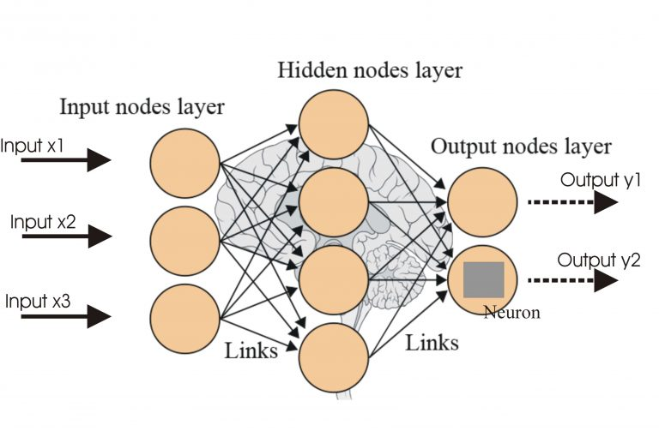
Source: Ali & Ahuja (2020).
- Natural Language Processing (NLP), as its name aptly suggests, is a field concerned with computers being able to process and understand human language in its original form. NLP deals with complexities of ubiquitous ambiguity present in everyday communication – the ambiguity that, on one hand, doesn’t present a problem to humans who understand connotative and denotative styles of interpretations, and yet are a big issue for programmed systems that are not familiar with such nuances (Goyal et al., 2018). What complicates the matter even further is the notion that ambiguity is a multi-faceted concept that encapsulates different issues present when interpreting text. Types of ambiguity include: lexical (one word having multiple different meanings), syntactic (one sentence being able to be parsed in multiple different ways leading to different meanings), semantic (the meaning of the sentence itself can be interpreted in multiple ways), language errors (when different interpretations are possible due to the errors in grammatical construction of sentence which are still comprehensible) and pragmatic (when multiple different interpretations are possible depending on the context), with other categorizations existing concordantly (Bano, 2015). Some of the applications of NLP include: speech recognition, chatbots and text summarization (Goyal et al., 2018).
- Besides processing and understanding textual stimuli, artificial intelligence can be utilized for visual stimuli as well, which is what the field of computer vision is concerned with. In the narrower sense, the main goal of computer vision is extracting information from input that is in the form of images, although additional goals such as implementing transformations for the purpose of enhancing the quality and interpretability of those images is often attributed to this field as well (Wiley & Lucas, 2018).
- While the previous industrial revolutions commenced with the progress in robotics in the terms of successfully using machines as tools for strenuous manual labor, the AI has significantly contributed by working on the layer of autonomy the machines may additionally possess during their work. This autonomy reflects in machines being able to recognize the circumstances, create predictions based on them, formulate an action plan as a response and execute the plan, all of these steps performed without external input from humans in the form of commands (Perez et al., 2017).
- Lastly, the field that is going to be described into more detail in the following chapter, machine learning (ML) refers to algorithms that computers (or machines, in general) use to learn how to perform certain tasks or provide certain outputs (in the context of the data being handed to them), without being explicitly programmed to do so (Mahesh, 2020).

Definition and types of Machine Learning
The more elaborate definition of machine learning would be that it is based on experiential learning of machines in order to: recognize patterns in large amounts of input data, perform repeated self-optimizations, and then to be able to compute (or predict) its own related outputs once the new set of related data is provided. These outputs that the machine created are then assessed in the terms of accuracy and other context-relevant attributes, so that the consequential findings would be used to further improve the machine’s ability to compute future outputs later on. This entire process is iterative in nature until the results are satisfactory (Helm et al., 2020).
While this definition provides a basic framework for all of the machine learning algorithms, still there are certain significant differences in approaches, which led to the categorization of the ML field into: supervised, unsupervised and reinforcement learning.
- Supervised learning techniques are used in conditions when both the input data as well as the output target values are provided to the machine. With the output target values being determined before the learning process has started, it is specified which types of input-output pairings are expected a priori, and the task is reduced to either categorization (if the target values are of categorical nature) or regression (if the target value should represent a continuous value) (Sarker, 2021). Given the need to actually provide the expected types of output, this type of learning necessitates bigger role of human involvement.
- On the other hand, unsupervised machine learning includes far less of human involvement in the process, as it only consists of recognizing patterns or structures in the unstructured data that it has been given as an input. The input data, on its own, is a collection of noise, seemingly randomized, and the algorithms are used to make some sense beyond that and provide a certain organization as an output (Ghahramani, 2004). To that extent, two elementary tasks of unsupervised learning are clustering – aiming to identify subsets of input data in which the elements are more similar to each other than they are to the elements assigned to other isolated subsets (Serra & Tagliaferri, 2019), or dimensionality reduction – aiming to calculate the relative importance of features in the input data and consequently reduce the input to the subset of those (Dash et al., 1997).
- Lastly, reinforcement learning is based in the principles of “trial-and-error” as well as the “law-of-effect” by having machines (or as they are usually called in this field, agents) commence the performance of the tasks, experience certain positive or negative feedback as a result of their actions, and course-correct their future plan of actions in the following iterations. It is based on the concepts of: reward function, state and action, policy and value function. The reward function represents the sets of predetermined scalar or integer variables that may be encountered after each of the agent’s action, and that denote whether the performed action was beneficial or not to the agent’s goal. To that extent, action represents any decision made by the agent that was made or that needs to be made as a result of the agent’s learning, while state indicates the current environment in which the agent resides with all of its available information. The policy, in turn, alludes to the mappings of possible connections between the states and the actions available in the task, akin to the associations between the available stimuli and responses of an organism in any given context. The value functions, accordingly, indicate the level of benefits the agent experiences or might experience by being in a current state, performing a certain action or changing through actions to a different state (Sutton & Barto, 1997). The presented structure of reinforcement learning typically suits the so-called SARSA or state-action-reward-state-action technique where the agent follows the available policy and might not always choose the path with the biggest possible net of rewards as there is a modicum of randomization in the choosing of the actions and any action that is net positive would suffice (Figure 4).

Figure 4: SARSA model of reinforcement learning
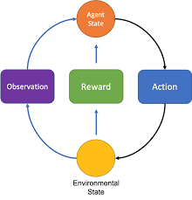
Source: McClellan et al. (2019).
There is another technique of reinforcement learning called q-learning where there is no policy available and instead of a randomized approach it specifically targets only the actions that lead to the biggest available reward, thus aiming to accomplish the highest optimization possible while performing the task (Zhao et al., 2016).

Methodologies for Machine Learning Development
The process of building a machine learning system entails the thorough implementation of sequential steps necessary in order to obtain reliable results and a successful ML system that will be available for re-use in the future. There are multiple approaches to this issue that mostly compare and differentiate the ML development against the process of traditional software development. Some of the key differences are reflected in the fact that the traditional software development process is linear and utilizes a set of pre-established rules in a prescriptive manner, while ML development consists of iterative sub-processes, adapting in regards to the feedback obtained after various steps, and is primarily data-centric, additionally adapting to the input data and the context it works in (de Souza Nascimento et al. 2019).
While there might be slight disagreements about the specifics regarding the methodology for the ML development, there are some basics that are in most part agreed upon (Figure 5). These basics refer to the universal stages of the ML development, those being: data management, model learning, model verification and model deployment (Ashmore et al., 2021).

Figure 5: Phases of ML development methodology
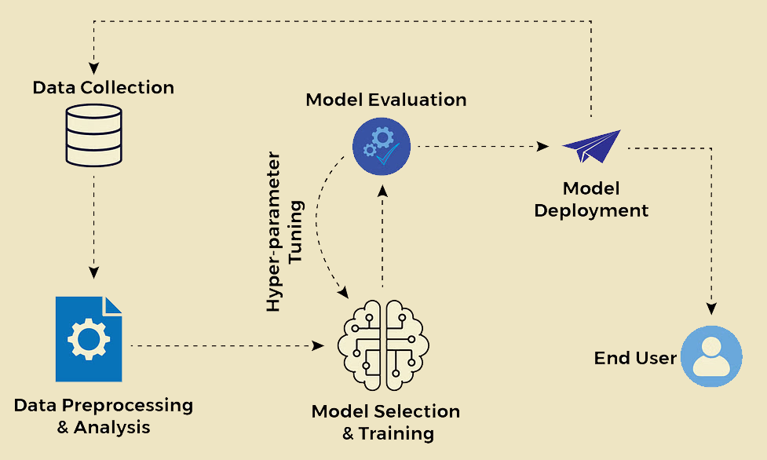
Source: Sarkar (2024).
- The data management phase centers around obtaining and preparing the data for further analyses. It deals with the activities surrounding the collection of data from the designated sources, preprocessing data by ensuring that the raw collected data has been transformed in a form suitable for conducting analyses upon them, and analyzing the data in an exploratory manner to provide better insights into relationships between the variables as well as to detect any errors (missing data, outliers) that may be an issue later on.
- Model learning phase centers around the very creation of the model. In this stage, the type of the model is decided upon as part of the model selection, after which the training of the model is performed by dividing the sample data into training and test datasets. Training dataset is couple times larger in comparison (precise ratio depending on the size of the sample and nature of the task) and is used in order to obtain the internal parameters of the model (weights, for example) with the purpose of minimizing possible errors. The leftover test dataset is then used to assess the model’s success at generalizing on new data that which it managed to learn in the previous step. One more relevant step of this phase includes the hyperparameter tuning, or the adjustment of the training process’ parameters in order to ensure the functionality of the model, however there aren’t any agreed-upon specifics as to how the hyperparameters ought to be tuned.
- The next step that is crucial in order to successfully deploy the ML model is the assurance that it will adequately work on data different than the training dataset it was already exposed to and upon which it learned, and it is called model verification. There are numerous ways on how to verify the model, and they could be divided into the two groups of test-based verifications and formal verifications. Test-based verifications depend on the various relevant pre-established criteria in regards to which the model would be deemed as successful, while the formal verifications are based on the mathematical equations that strive to provide irrefutable mathematical evidence that the model is in accordance with what is required from it. The choice of the verification is largely domain-specific and differs from model to model.
- Once it has been verified that the model satisfies the necessary requirements, the phase of model deployment may commence. If the ML model is supposed to be a part of a larger system, what follows is an attempt at integration of the model into the architecture. Regardless, however, of whether the model is a component or a stand-alone, the monitoring is an essential part of this phase, where the model’s future actions are being tracked, as well as the inputs that are provided to it and other circumstances in which it operates, in order to ensure that no unexpected errors occur. If needed, updating is also a crucial component of this phase, especially for the models that are designed to be used multiple times over large periods of time (Ashmore et al., 2021).

USE OF ARTIFICIAL INTELLIGENCE IN THE FOOTBALL BETTING INDUSTRY
The third chapter of the thesis offers a brief overview of the history of betting, focusing on the domain of football betting in Europe especially. It covers the financial influence and relevance of betting for certain European countries, the growth of both in-person and online forms of betting, as well as some basics of the betting odds. Furthermore, the applicability and usefulness of artificial intelligence is presented, as well as the success of machine learning algorithms for both predicting the match outcomes and achieving profitability at the same time, put into the context of comparing the ML models with the leading betting companies in the industry. As multiple ML algorithms have been utilized for the purposes of this thesis, various families of algorithms and their representatives have been described and mathematically explained – in particular: logistic regression (for the probabilistic distinctive classifiers), support vector machine (for the geometric distinctive classifiers), and gradient boosted trees and extreme gradient boosting (both for the boosting ensemble classifiers). Aiming to increase the quality of the methodological approach to constructing an ML model, the procedure of nested cross-validation has been utilized as well, and for that matter the basics of cross-validation, both k-fold and nested, have been additionally covered here.

Overview of the Domain of Football Betting and Odds Compilation
The practice of betting, in general, refers to playing a “game” of attempting to predict what will the outcome of a certain event be, in part based on the assessment of the skills of the participant, while acknowledging that in part the outcome will depend on the matter of chance as well (Kargün et al., 2020). Putting it in the particular context of football, it represents placing the arbitrary sum of money on one personally-chosen outcome of the football match out of many possible ones, and after the end of the match, if chosen correctly, receiving a financial compensation proportional to the invested sum of money as well as to the odds (probabilities) that were designated to that certain outcome (Turcu et al., 2020).
Betting has been present as a form of entertainment for the masses for almost two millennia as far as we know, with one of the first documented evidences being present in the Juvenal's “Satire” from the second century AD (Pradier, 2019). However, the history of betting was plagued with struggles for legalization, being famously banned by the King Henry II of England in 1188 for his crusaders in order to preserve their virtue (Lapina, 2016), while in the more recent times the “Professional and Amateur Sports Protection Act” that lasted from 1992 till 2018 had outlawed all betting practices in 46 out of 50 US states (Holden, 2018). The liberalization and legalization of sports betting and other forms of gambling has been on a noticeably progressive route since the beginning on the 21st century in Europe as well, mostly due to the appeal it has for the tourists, and for the financial gains the country ends up with. To that extent, a time-series based research was conducted involving countries from Central and Eastern Europe, which has shown that, amongst the sample, Italy presented the biggest share of betting in GDP with 5.68% and 95 billion euros in 2016. At the same time, Slovenia was among few countries that recorded a significant drop in the shares that betting had in the GDP, explained by the simultaneous increase in GDP and stagnation of betting revenue over years, and in 2016 it contributed to 0.77% of GDP, or 306 million euros at the time. Still, the picture on the global level showcased that sports betting added up to 0.60% of GDP, or 450 billion US dollars total (Raspor et al., 2019).
One more progress appearing in the field of sports betting is the emergence and growth of online betting, an alternative to the traditional in-person approach. The traditional approach, which still amounts to more than 2/3 of EU betting market, consists of individuals visiting the physical betting markets in person and placing bets on singular or multiple sport events such as football matches, and paying in cash (Gross & Rebeggiani, 2018). On the other hand, while the process of the online form of betting is pretty similar in the terms of placing bets, it still offers numerous advantages over in-person alternative, such as: having 24/7 working hours, being available on any devices that can establish internet connection, as well as providing greater sense of anonymity and multiple paying options, including cryptocurrencies (Granero et al., 2020). And while its share is still evidently inferior to the traditional forms of in-person betting, the online alternative has consistently been growing, and is projected to go from 17.5 to 22.5% of market share in Europe, or in financial terms to go from 88.2 to 109.2 billion euros of overall market revenue (Gross & Rebeggiani, 2018).
Both the in-person and online betting primarily use the so-called betting odds as basis for their operating. The bookmakers are individuals that, based on their expertise knowledge, the historic data available and, in recent times, various statistical analyses, set the probabilities for various possible outcomes of sports events (e.g. football matches). In Europe, transformation into decimal format is conducted by the equation of $\frac{1}{ p}$, where $p$ signifies the given probability of an outcome to show the likelihood of the event occurring; although there is a myriad of other, less popular formats, such as the one used primarily in UK that follows the equation of $\frac{p}{1-p}$ which aims to show the ratio of the potential profit to the initial bet (Cortis, 2015). Besides the format, the odds can be categorized according to one more criteria – whether or not they may change in the timeframe between their initial release and the start of the event. Those that may not change are aptly called fixed-odds and are still mostly used in the in-person forms of betting, as they are usually printed a couple of days in advance of the events for the customers to place their bets on. Contrary to that, online betting is primarily based on the odds that are allowed to be dynamically adjusted as a response to the influx of new information regarding the event itself or the happenings on the betting market, until they become “closing odds” right before the start of the event (Vlastakis et al., 2009).
The process of the odds’ setting itself has evolved significantly over time – in the earlier days, it depended completely on the experts’ knowledge and the information they accrued from various sources; nowadays, historic data is used instead, in combination with powerful analytic methods that utilize AI for the calculations.

Role of Artificial Intelligence in Football Betting
The trend of using algorithms that are based on AI, in order to compensate for human limitations, does not come as much surprise in this day and age. The data from one of the many articles that researched the efficiency of AI for football betting calculated the speed and accuracy of their most successful algorithm. The results have shown that it was able to analyze 4561 matches, took only 0.0156 seconds to prepare and less than 0.0001 seconds to create predictions which achieved the scores of 0.5652 for the f1 parameter (metric that measures a model's accuracy) and 0.6000 for precision (Andrews et al., 2021). Such numbers showcase the impressive power of AI over human capabilities, in the terms of large amounts of information, speed of processing and most importantly, high levels of accuracy and precision in such short period of time. Even with such indicators, many researchers attempted, and ultimately failed, to show the superiority of human expertise, as models had consistently shown the higher accuracies as well as higher monetary winnings (Pretorius & Parry, 2016).
Alongside the number of individual papers on the topic, meta-analyses have also been written regarding the accuracy of AI for sports betting purposes, and one of the larger ones managed to review 39 papers published between the years of 1996 and 2020. Its results provided an optimistic insight across various sports, showing that accuracies for all of the sports taken into consideration are above 55%, with European football (“Soccer” on the x-axis) being around 65% and American football (“Football” on the x-axis) reaching almost 75% accuracy, as can be seen in the Figure 6 (Horvat & Job, 2020).

Figure 6: Accuracies of AI algorithms used for betting across sports (US terminology)
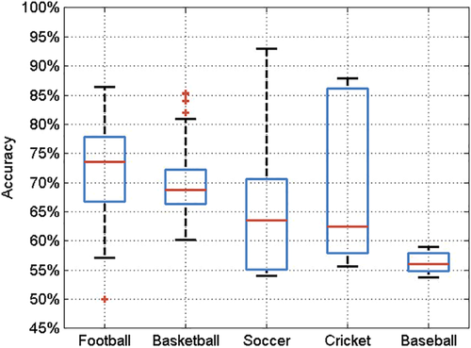
Source: Horvat & Job (2020).
The meta-analysis additionally provides an even deeper insight with results about successes of particular AI or ML algorithms that were used in the researched papers. Given that there are various “families” of algorithms, it does matter which one is being used, as some groups may be more adequate and thus more successful than the others. Particular groups and their representatives are further explained in more details in the following chapter, and for now the relevant options are, as shown in the Figure 7 below: Neural Networks, Support Vector Machine (SVM), Regressions (Linear or Logistic), Naïve Bayes, Decision Trees/Random Forests (or Ensemble algorithms) and their counterparts of Boosting algorithms. The figure in question shows the accuracies of the algorithms, their maximums portrayed by the size of their circles, inside of which the medians for the accuracies are written. At the same time, the color of the circles indicates which algorithms were more often used in which sports, the darker shades meaning that the particular algorithm was used more frequently for the particular sport. The appearance of outer circles being far from the inner circles indicates that the distribution of the results was skewed positively or to the right, meaning that there was a small number of very high results while the majority was on the lower end. Taking European football (or “Soccer”, as written in the figure), as a relevant sport for this thesis, it can be seen that almost all of the distributions were positively skewed, to bigger (Naïve Bayes) or lesser extent (SVM). Disregarding the “Other” option as well as the mentioned Naïve Bayes that, due to its naivety of not allowing features to correlate amongst each other, has frequently shown to underperform (Jadhav & Channe, 2016), it can be seen that the accuracies for predicting football matches’ outcomes ranges consistently from 65 to 70% across the algorithm types (Horvat & Job, 2020).

Figure 7: Accuracy of AI algorithms for predicting purposes across various sports (US terminology)
Source: Horvat & Job (2020).
With such results showing the success of AI algorithms for the purposes of football betting, there was a research that directly pitted the AI against the success of betting odds from two reputable betting companies – Bet365 and Pinnacle Sports. Even though official bookmakers, such as those that work for mentioned organizations, have much deeper insights and significantly wider access to data that are not free-to-use for public and researchers alike, the results were once again quite promising. Namely, they calculated the ranked probability scores (RPS), which measure the success of predictions against the actual observations, for the algorithms that they used and the betting organizations’ odds for the seasons 2014/15 and 2015/16 for the English Premier League (EPL), whereas the value of 0 would indicate complete accuracy and the value of 1 would indicate complete discrepancy between the forecasted and actual results. It was shown that the algorithms, albeit somewhat inferior to organizations’ bookmakers, were still only outperformed by a margin of around 0.014 in the case of their best model (gradient boosting), as shown in the figure 8 below (Baboota & Kaur, 2019).

Figure 8: Ranked Probability Scores for betting organizations and AI algorithms
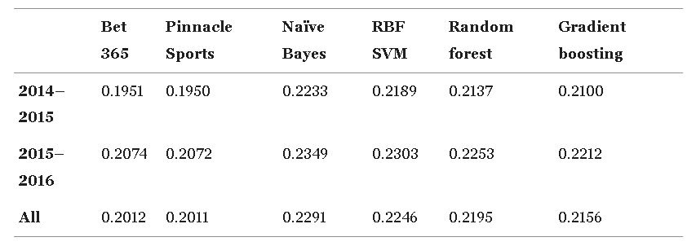
Source: Baboota & Kaur (2019).
Besides being on par with betting organizations’ bookmakers in the terms of accuracy for predicting the football matches’ outcomes, the researchers elsewhere have additionally investigated the profitability of using AI algorithms spanning 5 seasons of English Premier League, from 2013/14 till 2018/19. The analysis covered all of the fixtures across entire seasons, with there being 38 fixtures in total for every year. The results showcased the consistency of algorithms’ performances, achieving profits in 30 and mostly minor losses in only 8 of the fixtures – accruing an average profit margin of 26.78%, as it can be seen in the figure 9 below (Rodrigues & Pinto, 2022).

Figure 9: Achieved profits by fixtures using AI algorithms for football betting
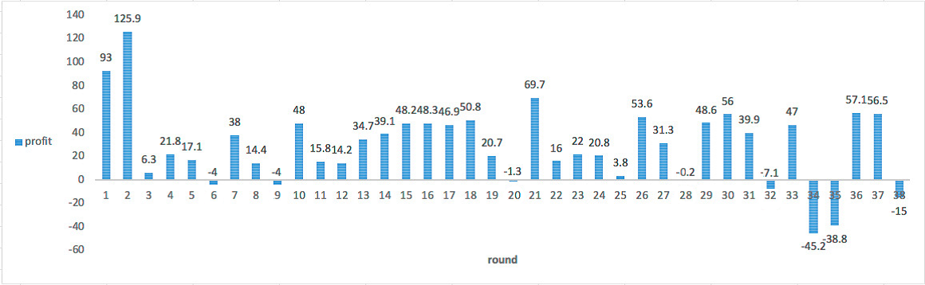
Source: Adapted from Rodrigues & Pinto (2022).

Overview of Machine Learning Algorithms
As it was previously mentioned, there are multiple families of algorithms covered by the umbrella term of AI, or more specifically its subset of ML. To that extent, for the purposes of this thesis, in order to adequately assess the efficiency of ML algorithms for football betting, I have decided to utilize one representative from each of the notable clusters. Those clusters or families being: discriminative probabilistic models (represented by logistic regression), discriminative geometric models (represented by support vector machine) and ensemble models (represented by gradient boosted trees and its enhanced version of extreme gradient boosting).

As it will be relevant for the justification of the choices made, as well as for the better understanding of the analysis that follows (logistic regression), the basics of the probability theory will be presented here. Probability theory is a mathematical approach to quantifying events that contain a certain amount of uncertainty (as most events naturally do), and manipulating these uncertainties in various ways, such as making predictions for events in question. These predictions can be made by inferring possible models that could be used to explain the available data regarding the events. Furthermore, by using these models, it is possible to make additional predictions about future data that was not previously available, which in its core represents the fundamental essence of machine learning (Ghahramani, 2015). Some of the core concepts of this theory are: sample space (Ω) – all possible outcomes of a certain experiment; event – a subset of the sample space, corresponding to one or more of the outcomes (Ash, 2008); field (Ƒ) – collection of sample space's Ω subsets; probability – likelihood of a certain event happening; probability function (p) – a function that assigns probabilities to certain events from the sample space.
The probability function p obeys the so-called Kolmogorov's axioms that state the following: for the event A, p(A) ≥ 0 for all A ∈ F (non-negativity); p(Ω) = 1 (normalization); adding another event B, p(A ∪ B) = p(A) + p(B) for all A,B ∈ F such that A ∩ B = ∅ (finite additivity). An important observation to make is that these probabilities of events up until now were unconditional, or in other words, the likelihood of event A happening was not dependent or affected by the likelihood of event B happening. However, as is the case in machine learning models, there are circumstances when we wish to determine the likelihood of an event happening based on the existence of other previously recorded events (in other words, the likelihood of a certain outcome based on chosen relevant predictors of that outcome). For such cases, the mathematician who introduced axioms for unconditional probability has also introduced the conditional probability, wherein the probability of event A in the context of a previous event B is $p\left(A | B\right)=\frac{p\left(A ∩ B\right)}{p(B)}$, provided p(B) > 0 (Hájek, 2011). In further references, as is customary in the field of machine learning, the outcome event A is denoted as y instead, while the previous event or the predictor B that the outcome is conditional upon is denoted as x.

Discriminative models – probabilistic and geometric
When it comes to probabilistic models, based in probability theory, that are particularly concerned with determining conditional probabilities of certain outcomes in regards to various predictors, they can be further divided into groups of generative and discriminative models (even though not all of the models belonging to these subtypes are necessarily probabilistic models in nature as well, which will be relevant later on). Both of these types of models can be used for the task of classification, however they tackle it in a vastly different manner. Generative models approach the issue by modeling the joint probability of predictors and outcome p(x, y), making the predictions to calculate the conditional probability of $p\left(y | x\right)$ (previously $p\left(A | B\right)$) as well as the probabilities of$p\left(x | y\right)$ and p(y), and then assigning the most adequate outcome y from the set of possible outcomes. On the other hand, discriminative models, which are more relevant to this thesis, do not model the joint probability p(x, y) and do not concern themselves with other probabilities such as$p\left(x | y\right)$ or p(y), and instead directly model the $p\left(y | x\right)$ focusing on the boundaries between classes, thus usually being more preferable for the classification purposes such as the one this thesis is about (Ng & Jordan, 2001).

Logistic Regression
Focusing onwards on discriminative models for the reason stated above, out of those that can be considered as probabilistic models as well, a particular one that is in the epicenter when it comes to machine learning and classification is the logistic regression. The logistic regression as a model is used in its most basic form to determine the probability of a binary outcome (when the variable corresponding to the outcome y contains only two distinct events) based on the inputs or predictors x (one or many), while usually following the Bernoulli distribution, the most adequate one in such a scenario (Zhang & Wang, 2017). Written mathematically, the conditional probability with w as the added weight of the model, $p\left(y | x, w\right)$ becomes equal to Ber$\left(y | μ(x)\right)$, where $μ\left(x\right)=E\left[y | x\right]=P(y=1|x)$. The scalar product between the input vector x and the vector of the model's weight w is calculated as w^{T}x, becoming $μ\left(x\right)=$ w^{T}x. However, the crucial part for the logistic regression, as there are only two classes of outcome possible in its binary form, is to pass it through the function of 0 ≤ μ(x) ≤ 1, for the form of $μ\left(x\right)=$ σ(w^{T}x), where σ refers to the sigmoid function. The sigmoid function, otherwise known as logistic function due to its application, maps the entire linear combination of the product w^{T}x to the probability space of [0,1]. When the $μ\left(x\right)$ that has undergone sigmoid function transformation is put back into the formula for conditional probability under Bernoulli distribution, the final form of logistic regression is $p\left(y | x, w\right)=Ber(y|$σ(w^{T}x)) (Murphy, 2012).
And while this approach showcases the probabilistic background of logistic regression, it should be noted that it is a somewhat less-opted-for route for explaining this algorithm. The more often utilized “logit-based” approach still starts off from Bernoulli distribution, but in its essence it deals more with the interpretability of the analysis’ results. The probability mass function of the Bernoulli distribution for the observed binary variable y can be written as p(y) = p^{y}(1 − p)^{1−y}, and it is additionally assumed that this outcome variable is based on a continuous variable with a density function for y_{i} = 0: p(y_{i} = 0|x_{i}) = 1 – p being $\frac{e^{-y}}{1+e^{-y}}$ . Furthermore, the likelihood of y_{i} = 1: p(y_{i} = 1|x_{i}) = p amounts to $\frac{1}{1+e^{-y}}$ , which corresponds to the previously mentioned sigmoid function σ that maps the linear outcomes of a continuous variable to the binary space [0,1]. This is where the logit-based alternative provides an advantage, as the inverse function of this sigmoid formulation $\frac{1}{1+e^{-y}}$ , or in other words the logit function of it, results in logit(p_{i}) = log($\frac{p_{i}}{1-p_{i}}$) = y (Zhang & Wang, 2017).
The outcome y can also be written as α + βx, where α is the intercept when predictor equals 0 and β is the coefficient of change for the predictor x. By exponentiating the y in this form as exp(y), the resulting e^{α}(e^{β})x provides the useful interpretation of β – now as e^{β} , it quantifies the effect of x on y by representing the multiplicative factor of change in y (Δy) when x increases for one unit, otherwise known as the odds ratio (Agresti, 2007). The incremental addition of logit-based formulation of logistic regression lies in its providing of the interpretation of odds besides the previously available interpretation of probability, which in itself is a crucial distinction. While probability in itself represents the ratio of favorable outcome's likelihood to all of the possible outcomes, the odds ratio now represents the ratio of the probability of the favorable outcome and the probability against that same outcome – which is fundamental for understanding the results of analyses that predict events with binary outcomes in particular (Sperandei, 2014). This is one of the core reasons why logistic regression, especially in the form of its logit-based transformation, is used for analyzing such events and consequently why it was used in this thesis as one of the algorithms for predicting the likelihood of the football matches' outcomes.

Support Vector Machine
The other distinctive classifier, that has a completely different approach to the probabilistic one, and yet is an excellent algorithm for the classification task, is the support vector machine (SVM). The SVM doesn't calculate the likelihood of the input data which would lead to a certain class of the outcome events, and instead belongs to the family of geometric distinctive classifiers. In other words, it uses the technique of plotting the input data into a multidimensional space and subsequently calculates the boundary between various points of data in the said space. In order to do so, SVM consists of number of steps that perform various calculations before performing the actual classification. First of all, the input data x, or the features that serve as the basis for classifying the outcome label y, are being mapped into the multidimensional space so that (x₁,y₁), …,(x_{ℓ}, y_{ℓ}) ∈ R^{N} × {±1}, where N is the number of the x features. Using this data as a training set, SVM attempts to estimate the f:R^{N}→{±1} function so that it will be able to use it to classify new data of f(x) = y for examples (x, y) that is assumed to be generated under the same underlying probability distribution p(x, y) as the training data (Hearst et al., 1998). Once the input data has been plotted in a coordinate systems where the axes (x-axis, y-axis and so forth) correspond to the features at first, the next step is to delineate the so-called convex hulls if possible. In the simplest case where the data is plotted in a two-dimensional space, and it is possible to view them as clusters of two different classes that are linearly perfectly splittable, the outer boundaries of the clusters of data are called the convex hulls, as it can be seen in the figure 10 (Lantz, 2013). Once these boundaries of data clusters have been determined, the shortest line between the two points closest to each other of each of the two hulls is calculated, called the margin and represented by the dashed line in the figure 10. The points of the clusters closest to each can also have their own lines projected perpendicularly to the dashed line as well, with these lines being called the support vectors. All of this is needed in order for the algorithm to be able to calculate the boundary line, or the bisector of the shortest distance between the support vectors, that is perpendicular to the margin's dashed line and is called the hyperplane (also present in the figure 10 as a diagonal full line splitting the dashed line or the margin).

Figure 10: Plotting the data and determining convex hulls in SVM
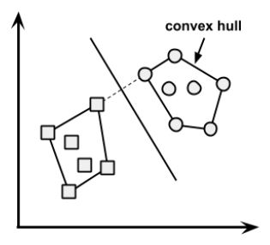
Source: Lantz (2013).
Mathematically, in order to determine the hyperplane that separates the data into outcome classes, the equation that is used is $\vec{w}$·$\vec{x}$+ b = 0 ˄ w ∈ R^{N}, b ∈ R, where w is the vector of n number of weights {w₁, w₂, …, w_{n}} perpendicular to the hyperplane, while b is known as the bias. Before finding the ideal hyperplane as a boundary line, the two outer hyperplanes, called the margin hyperplanes are calculated as $\vec{w}$·$\vec{x}$+ b = +1 and $\vec{w}$·$\vec{x}$+ b = -1 for each of the sides, with these margin hyperplanes being located in the same space where the previously mentioned support vectors lie. Once this was set, the position of the actual classifying hyperplane needs to be optimized between the margin hyperplanes. The optimization is performed by first defining the distance between the support vectors or margin hyperplanes (the margin itself) as $\frac{2}{\left\|\vec{W}\right\|}$ , where $\left\|\vec{w}\right\|$ represents the Euclidean norm or $\sqrt{w_{1}^{2}+w_{2}^{2}+…+w_{n}^{2}}$ indicating the distance from the origin to the vector w. Then the SVM seeks to minimize the $\left\|\vec{w}\right\|$ in the form of min_{w,b} $\frac{1}{2} {\left\|\vec{w}\right\|}^{2}$, which means the same as maximizing the margins, subject to y_{i}($\vec{w}$⋅$\vec{x}$_{i}​ + b) ≥ 1, ∀$\vec{x_{i}}$ . What this minimization formula ensures is that the classification is successfully performed, so that data points that are (y_{i} = +1): $\vec{w}$·$\vec{x}$+ b ≥ +1 , in other words that are over that margin hyperplane, belong to the positive outcome class, while the (y_{i} = -1): $\vec{w}$·$\vec{x}$+ b ≤ +1, or the data points that are over the other margin hyperplane, belong to the negative outcome class (Lantz, 2013). This entire procedure of determining the boundary line in the form of hyperplane in the geometric space of input data and features is visually presented below in the figure 11, where one more possible alternative yet non-optimal hyperplane is also present in order to showcase the difference between it and the optimal one. However, an important observation to be made here is that this is the case of the ideal circumstances where the input data belonging to two different outcome classes are completely exclusive and separable by a straight line from each other, forming two perfectly homogenous clusters of data on either sides of the hyperplane. In reality, however, this is almost never the case.

Figure 11: Calculating the optimal hyperplane as a boundary line in SVM
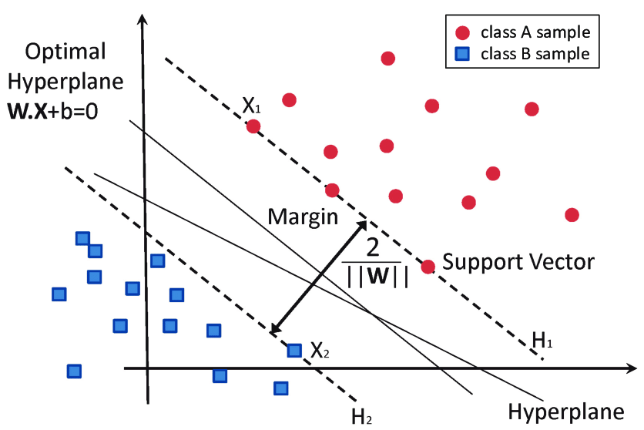
Source: Garcia-Gonzalo et al. (2016).
A much more realistic scenario involves some of the data not being on the correct side of the hyperplane, thus being wrongfully categorized as the outcome class other than the one it actually belongs to. And while such circumstances are pretty much inevitable when working on real-life data, fortunately the SVM algorithm has an ameliorative solution to that as well – utilizing the so-called slack variables (ξ). A slack variable allows for some data to be misclassified by introducing the “soft margin”, as it can be seen below in the figure 12. So, while the dataset begins from the same point of (x₁,y₁), …,(x_{ℓ}, y_{ℓ}) ∈ R^{N} × {±1}, the additional slack variable ξ leads to a bit of an update in the minimization of $\left\|\vec{w}\right\|$, which is now subject to: y_{i​}($\vec{w}$⋅$\vec{x}$_{i}​ + b) ≥ 1 – ξ_{i}, ∀$\vec{x_{i}}$, ξ_{i} ≥ 0. With this taken into consideration, the optimization of the hyperplane takes into account the additional cost value (C) as well, that is applied to all of the instances where the misclassification occurs. Thus, instead of maximizing the margin, the goal with soft margin SVM is to minimize the total cost of misclassifications, which now takes the form of min_{w,b,ξ} $\frac{1}{2} {\left\|\vec{w}\right\|}^{2}$+ C$\sum_{i=1}^{n}{ξ}$_{i} (Lantz, 2013). It should be noted that the cost value C works in such a way that, the higher the value of C, the SVM algorithm will give more advantage to the lower percentage of misclassification, which in extremes leads to much smaller margins and thus overfitting. On the other side, the lower the value of C, the misclassifications are bound to occur more, however the model will be more generalizable on the new data that did not belong to the training set. With this in mind, it is the matter of a trade-off that differs from context to context.

Figure 12: Soft Margin SVM for non-linearly separable data
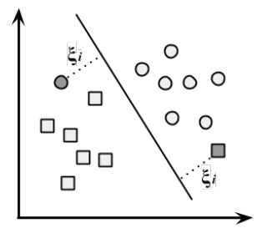
Source: Lantz (2013).

Besides the real-world data in most cases not being separable perfectly by a straight line, there is one more issue that needs to be addressed – the cases where the separation of data is non-linear to such extent that even the allowance of some extent of misclassification is far from enough for the successful classification of data. This distinction can be seen below in figure 13, where 13a) shows the usual linear problem, that could withstand some small instances of non-linearity in the form of some data being on the wrong side of the hyperplane, while in 13b) the two clusters are so non-linearly separable that there is no hyperplane in two-dimensional space that would manage to create a boundary for the two classes.

Figure 13: Linearly vs Non-linearly separable data in a two-dimensional space
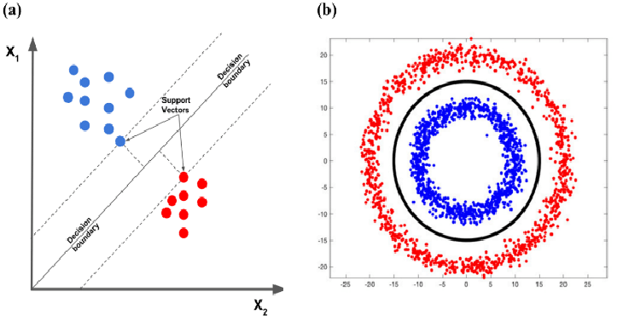
Source: Learn OpenCV (2018).
As it can be seen, there is a radial line that separated the red and blue class in the case of 13b), which is not something that SVM in its native form allows. However, fortunately again, SVM offers a solution in the way of the so-called kernel functions (K). A kernel function enables the transformation from non-linear to linear spaces, usually by performing the dot product of the feature vectors (such as x_{i} and x_{j}). For the x ∈ R^{d} where d represents the dimension input space, the non-linear transformation function is Φ(x) ∈ R^{m} with m being the dimension feature space. The optimization problem now becomes Q(α) = $\sum_{i=1}^{n}{α}$_{i} – $\frac{1}{2} \sum_{i=1}^{n}{α}$_{i}α_{j}y_{i}y_{j} {Φ < (x_{i}), Φ(x_{j}) >} in its dual form utilizing Lagrange multipliers, where the first term $\sum_{i=1}^{n}{α}$_{i} stands for the sum of all Lagrange multipliers, while the second term $\frac{1}{2} \sum_{i=1}^{n}{α}$_{i}α_{j}y_{i}y_{j} {Φ < (x_{i}), Φ(x_{j}) >} stands for the interactions between all possible pairs of the training samples. In order to avoid the costly computation of the dot product of Φ(x_{i}) and Φ(x_{j}) which is in a much higher dimensional space, the kernel function is introduced here. The optimization problem thus becomes Q(α) = $\sum_{i=1}^{n}{α}$_{i} – $\frac{1}{2} \sum_{i=1}^{n}{α}$_{i}α_{j}y_{i}y_{j} K(x_{i}, x_{j}), replacing the dot product of non-linear transformation functions with the dot product of features. With this put in place, the classification function that was in its original form of f(x) = sgn{(w·x)+b} now becomes f(x) = sgn{$\sum_{i=1}^{n}{α}$_{i}*y_{i} K(x_{i}, x_{j}) + b*} where the asterisk as a subscript denotes the optimal values of the corresponding parameters after the optimization process has been completed. And while so far the kernel function K(x_{i}, x_{j}) has been described as a simple dot product of the x_{i} and x_{j} feature vectors in a higher dimensional space (x_{i}·x_{j}), this is only the simplest form of the function called the linear kernel function. Besides this option there are several more, such as: polynomial kernel function, where K(x_{i}, x_{j}) = (x_{i}·x_{j} + 1)^{h} where h is the degree of the polynomial; Gaussian radial basis function kernel function, where K(x_{i}, x_{j}) = ℓ^{-||xi - xj||^2/2σ^2} with σ being the Gaussian parameter for the bandwidth or spread which controls the width of the function; and sigmoid kernel function, where K(x_{i}, x_{j}) = tanh(kx_{i}·x_{j} – δ), with k and δ being the kernel parameters (Liu et al., 2014). The graphic representation of the utilization of the kernel trick can be seen in the Figure 14 below, where for the two-dimensional non-linear data the Gaussian radial basis function kernel function was used.

Figure 14: Using Gaussian RBF kernel function for the non-linearly separable data
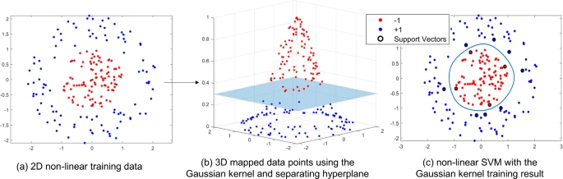
Source: Wang et al. (2024).

Ensemble methods
While the support vector machine offers an enhancement of its scope of analysis via kernel tricks for non-linear data, and is generally able to compute high dimensional spaces, it is still noted that there are unsatisfactory performances present when it comes to more complex data, whether this alludes to dimensionality and non-linearity itself or some other issues such as imbalanced or noisy data. For such circumstances, it is often advisable to, next to the traditional machine learning, utilize the algorithms from the family of ensemble methods of learning as well. The ensemble methods are still based on extracting the features that are going to aid the classification task, however their uniqueness lies in the approach of then using multiple weaker instances of classifiers that produce weaker results on their own, and combine the contributions of those into a stronger classification performance in the end (Dong et al., 2020). The most standard subtype of ensemble methods, called bagging, follows the broad definition quite closely in its approach – it consists of multiple instance of classifiers which are trained on the same data, however with each having a sample of their own drawn from the pool. The sampling is done with replacement, meaning that some data may be the same across different classifiers’ samples, while some data may not be used at all. Each of the classifier performs the classification task, and usually the prediction is based on the consensus of the majority, otherwise known as the voting method. The overall result is a composite model of these classifications performed, which may outperform a single classification being performed on the same data (Rokach, 2010). The visual representation of such ensemble learning in the case of bagging approach can be seen in the figure 15 below, where for the same pool of data (X), four instances of classifiers have been performed (cogs) with each giving their own prediction (1 or 2), and the final prediction being the class of 1 due to the majority.

Figure 15: Example of a voting method in the bagging ensemble learning
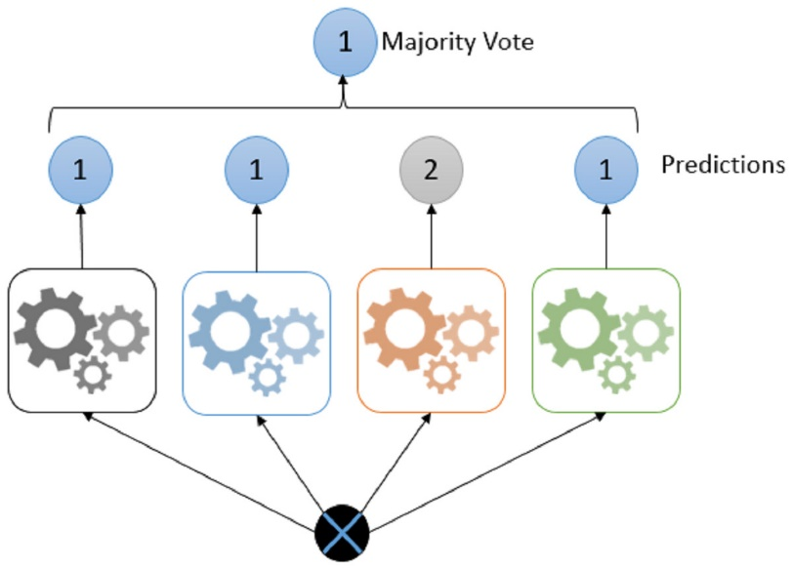
Source: Emanet et al. (2023).
However, there is another subtype of ensemble learning methods that has been shown to regularly outperform the bagging approach in general, called boosting. The boosting approach operates differently then bagging, even though they share the same traits of belonging to the ensemble family of methods (such as performing multiple weak classifiers and using their composite gained in some way or the other for the final classification model). The main difference lies in the fact that, in the case of bagging algorithms, the weak classifiers are conducted independently of each other, as was seen in the figure 15 above where the paths of the classifiers themselves do not intersect and instead their prediction results are taken into group consideration at the end of the process. On the other hand, in the case of the boosting approach, a weak classifier is being enhanced upon by sequentially conducting additional weak classifiers upon the previous one’s results, while the samplings are performed on various distributions of the same pool of the training data.
The iterative nature of the usage of multiple weaker classifiers can be seen in the graphic depiction of the boosting approach in the figure 16 below, where from the original data set the first sampling is performed for the first weak classifier (base learner 1 or Φ₁), calculating its error margin as well as its weight α₁. Following that, the second weak classifier (base learner 2 or Φ₂) samples from the original data set while additionally taking into consideration the weights of the previous base learner 1 for the training phase – thus learning about some differences in importance from the α₁ while performing its own process, and in the end providing its own error margins and weights α₂. The process is performed iteratively for as many s number of weak classifiers or base learners, where the final classifier Φ_{d} provides the error and weight α_{d} as well. Afterwards, the final prediction function f(x) of the entire boosting ensemble model is calculated as f(x)=$\sum_{d}^{s}{α}$_{d}​Φ_{d}​(X), representing the weighted sum of all of the base learners performed, and since each of the following classifiers have been trained by taking into consideration the misclassifications of the ones before them, together they provide much stronger final result. This final result of a model offers a classification performance that managed to be enhanced inside the model itself through these iterative instances.

Figure 16: Boosting approach of the ensemble learning methods
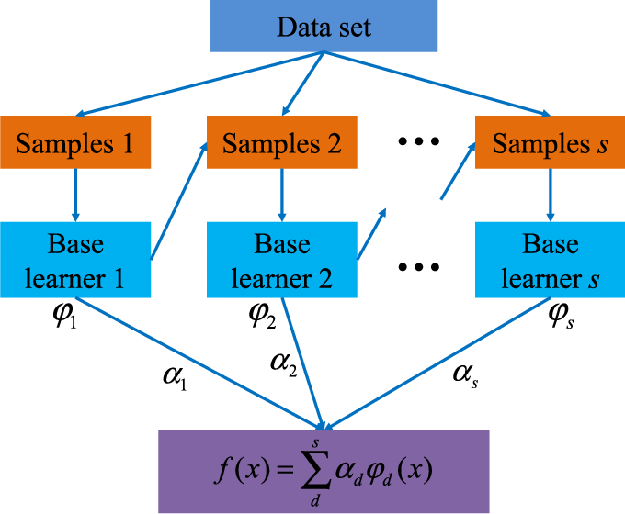
Source: Liang et al. (2020).
A research, which focused on the family of ensemble methods, aimed to investigate the efficiency and predictive capability of 11 different algorithms belonging to the bagging and boosting approaches – and has found that, overall, boosting methods have shown more promising results in comparison (González et al., 2020). Additionally, the same research has shown that, out of all of the ensemble learning algorithms, the one that has consistently shown the most success was the one called the gradient boosted trees (GBT), which is consequently going to be the first of the boosting algorithms used in this thesis.

Gradient Boosted Trees
The gradient boosted trees algorithm, as its name suggests, belongs to the family of boosting ensemble methods, while additionally being based on the gradient descent as its algorithm for the iterating optimization. To start with the gradient descent, the initial weight as a parameter θ is set, and the aim is to minimize the objective loss function J(θ) which corresponds to the error between the actual values and the values predicted by the model – in other words, to reduce the misclassification as much as possible. In order to do so, the gradient of the loss function $∇J\left(θ\right)$ is calculated, representing the vector of partial derivatives with regard to each parameter ($\left[\frac{∂J(θ)}{∂J(θi)}\right]$), which indicates the direction and rate of the function's steepest increase. Another relevant factor is the hyperparameter ρ that refers to the learning rate or the size of incremental steps taken towards the local minima (or the minimum cost) of the function. With these having been calculated, the weight parameter θ is updated in the form of θ := θ – ρ$∇J\left(θ\right)$, and these optimizations are repeated until the convergence to the minimum cost is achieved. The iterative process of optimization is graphically presented in the figure 17 below.

Figure 17: Gradient descent algorithm for iterative optimization
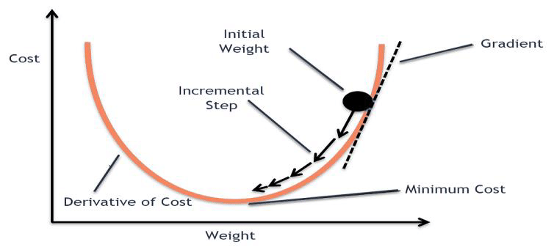
Source: Haji & Abdulazeez (2021).
Ensemble methods of machine learning, such as boosting, optimize in the function space rather than the parameter space, which means that instead of directly optimizing particular parameters of a single model they create a series of functions that are being combined. In other words, the function estimate$\hat{f}$ is parameterized in the additional form of $\hat{f}\left(x\right)={\hat{f}}^{M}\left(x\right)=\sum_{i=0}^{M}{{\hat{f}}_{i}(x)}$ where M is the number of all iterations and ${\{{\hat{f}}_{i}\}}_{i=1}^{M}$ represents the function increments or the “boosts” which is the basis for the name of the approach. Starting with the initial guess of ${\hat{f}}_{0}$, for each iteration the negative gradients of the loss function are calculated in regards to the predictions of the current model in the form of g_{t}(x)= – ${\left[\frac{∂ψ(y, f\left(x\right))}{∂f(x)}\right]}_{f\left(x\right)={\hat{f}}^{t-1}(x)}$ with ψ representing the particular loss function used. Additionally, the optimal learning rate or step size ρ is determined by minimizing the loss function at hand by the formula (ρ_{t} ,θ_{t})=arg min_{ρ,θ}$\sum_{i=1}^{N}{ψ\left(y_{i},{\hat{f}}_{t-1}\right)+ ρh(x_{i},θ)}$. The model is then updated by adding the new weak classifier which is scaled in regards to the step size, so that ${\hat{f}}_{t}←{\hat{f}}_{t-1}+ρ_{t}h(x, θ_{t})$. This entire proces is repeated either until the predetermined number of iterations has been achieved or until the convergence at the local minima is achieved (Natekin & Knoll, 2013).

eXtreme Gradient Boosting (XGBoost)
The last model used in this thesis is something akin to an extension of the gradient boosted trees, called the extreme gradient boosting (XGBoost or XGB). While they are both algorithms of the ensemble boosting family that are tree-based, there are some key differences that make XGBoost one of the most successful algorithms in this day and age when it comes to the learning tasks and competitions on complex data (Nielsen, 2016).
First and foremost, the XGBoost focuses on smoothing the final weights of the learning process in order to prevent overfitting of the model by using regularization. The regularization introduces the term Ω, so that the objective function is now in the form of $L\left(Φ\right)=\sum_{i}{l({\hat{y}}_{i},y_{i})}+\sum_{k}{Ω(f_{k})}$ where $Ω\left(f\right)=γT+\frac{1}{2}λ{\left\|w\right\|}^{2}$ , with T being the number of the leaves in the tree, $γ$ and $λ$ are the regularization parameters and $f_{k}$ is the instance of an independent tree structure in the entire model. So, while the first part of the objective function $\sum_{i}{l({\hat{y}}_{i},y_{i})}$ is once again the loss function that denotes the discrepancy between the ${\hat{y}}_{i}$ predicted values and the $y_{i}$ actual ones, the second part $+\sum_{k}{Ω(f_{k})}$ now additionally penalizes the model complexity which reduces the chances of overfitting. Naturally, if the Ω equals zero, the objective function is identical to the GBT.
Besides the introduction of regularization, the crucial distinction between GBT and XGBoost lies in the fact that the XGB is based on the Newton boosting trees which use both the first- and second-order derivatives. Since the loss function now for the t-th tree in the process is now $L^{(t)}=\sum_{i=1}^{n}{l\left(y_{i}, {\hat{y}}_{i}^{\left(t-1\right)}+ f_{t}\left(x_{i}\right)\right)+Ω(f_{t}) }$, it is non-linear by nature. In order to simplify the loss function and achieve faster optimization, the XGBoost uses the second-order approximation and thus transforms it into $L^{(t)}≃\sum_{i=1}^{n}{\left[l\left(y_{i},{\hat{y}}^{\left(t-1\right)}\right)+g_{i}f_{t}\left(x_{i}\right)+\frac{1}{2}h_{i}{f_{t}}^{2}(x_{i})\right]+Ω(f_{t})}$ with first-order gradient $g_{i}=∂_{\hat{y}\left(t-1\right)}l\left(y_{i},{\hat{y}}^{\left(t-1\right)}\right)$ and second-order gradient $h_{i}=∂_{\hat{y}\left(t-1\right)}^{2}l(y_{i},{\hat{y}}^{\left(t-1\right)})$ of the loss function. Removing the constants from the formula, the optimization takes the final form of ${\tilde{L}}^{(t)}=\sum_{i=1}^{n}{\left[g_{i}f_{t}\left(x_{i}\right)+\frac{1}{2}h_{i}{f_{t}}^{2}(x_{i})\right]+Ω(f_{t})}$. Since the approximation of the loss is now quadratic instead of non-linear, the optimization can be achieved faster, making it more efficient in general.
Two more differences between the GBT and XGBoost that lean into an advantage for the XGB are the techniques also introduced to reduce the chances of overfitting – shrinkage and column subsampling. For the first one, after each instance of boost in the model, shrinkage scales the newly added weights via the factor η, thus reducing the individual influences of the trees and facilitating the improvement of the model by the future trees. For the second one, since GBT uses all the features that are at disposal for each new tree added in the model, this slows down the performance and may lead to overfitting – the XGBoost on the other hand conducts column subsampling, meaning that for each new tree a subset of features are being used at random, bettering the performance on the new test data in the future. As its authors have pointed out, the main advantage of XGBoost overall lies in its scalability, as it is able to tackle large sets of data in high-dimensional feature spaces while utilizing minimal resources at that (Chen & Guestrin, 2016).

Relevance and Usefulness of the Nested Cross-Validation Procedure
It was explained briefly why the XGBoost is such a preferred algorithm for classification tasks, and one of the points is its inclusion of the techniques that prevent the occurrence of overfitting – something that is not inherent for the majority of other machine learning algorithms. The reason why this is such a relevant matter to be dealt with is the fact that the very nature of supervised machine learning is prone to overfitting in general. When creating a model by taking a learning algorithm and training it on a labeled training dataset, the model is inclined to fit the available training dataset the best it can, maximizing its accuracy on the training data. However, during the said fitting on the training data, it is almost inevitable that the model will get accustomed to some of the idiosyncrasies of this dataset. This, while unintentionally, still negatively affects the original task of the supervised machine learning, which is to transcend the boundaries of the training dataset and have the model be able to transfer its classifying ability on the new, previously unseen, datasets. The scenario where the model familiarizes itself with the training dataset, its noise included, and becomes dependent on it to such extent that its accuracy is significantly weaker when new data is provided, on which the model hadn’t trained before, is what is called overfitting (Dietterich, 1995).
The sole fact that the XGBoost as an algorithm has incorporated some of the precautions against it is almost enough to have it valued above other ML algorithms at their face value. However, different algorithms with their different approaches to classification may be more or less successful based on the nature of the domain and complexity of data available overall, and XGBoost is not excluded from this. For example, there has been evidence that XGBoost is known to regularly underperform in certain circumstances of complex datasets with additional high-dimensionality, especially if the datasets are small and imbalanced (Lin et al., 2022). Additionally, the number of parameters and hyperparameters that need to be tuned present another challenge that needs to be further addressed. Thus, in order to combat the overfitting issue for the rest of the ML algorithms that don’t necessarily do it on their own inherently, as well as to handle the mentioned possible disadvantages of the XGBoost, the most advised approach is to perform the process of cross-validation (Atsauri et al., 2023).
Cross-validation (CV), as one of the resampling methods, is used to estimate the ability of learning models to be generalized on previously unseen data – this is done by partitioning the available dataset into multiple instances of a small test subset and the remainder of the training subset, and comparing the accuracies between the models performed on each of these partitioning instances. While there are many variations of CV, the so-called k-fold method is perhaps the most widespread one. In it, the available or “learning” dataset L, is, naturally, split into training subset R and test (or “validation” for CV) subset V. However, the splitting is done multiple times in the manner of single hold-out method on the same L dataset, so that there are k number of pairs of R_{j} and V_{j} where j = 1…k, until the entire L dataset is exhausted, there being no overlap between the R validation subsets in all the k pairs as the resampling is done without replacements. This is presented in the figure 18 below, where for the entire L dataset in the scenario of 5 k folds, for the subset of “development data” the green partition represents the V_{j} validation subset for testing purposes, and the rest of the development data colored light blue represents the R_{j} training subsets, where j = 1…5. Usually, there is a subsample of the L dataset called “hold-out data”, colored orange in the figure 18, which is left out of the phase of model training and is in the end used as the true test T subset, given that it represents the data that is unseen to the model, and it is used only in the end after the model is trained on k number of folds as a mean of the final model evaluation.

Figure 18: An illustration of k-fold cross-validation with 5 folds
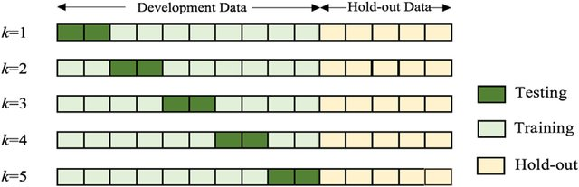
Source: Ghavami et al. (2019).
After the model has been put through all of the k number of folds with corresponding R_{j} training and V_{j} validation subsets respectively, the cross-validation averages all of the accuracies achieved on these sets of folds. Additionally, the prediction error ${\hat{ϵ}}_{cv}$ can be estimated for the model ${\hat{f}}_{-j}$, where –j denotes that the model was trained on all parts of the L learning dataset except for the j subset which can be characterized by the described hold-out subsample on which it was later tested. If the ${\hat{y}}_{i}={\hat{f}}_{-j}(x_{i})$ represents the estimated value of x_{i} case for the y_{i} label, the prediction error is estimated as ${\hat{ϵ}}_{cv}=\frac{1}{n}\sum_{i=1}^{n}{L(y_{i}, {\hat{y}}_{i}})$ where 𝓛 denotes the loss function of choice and n is the number of cases. And while the cross-validation in its generic form was shown to reduce overfitting on its own, there is a special case of it that further helps with the mentioned issue of hyperparameter tuning. This form is called the nested cross-validation (nCV) and as its name suggests, it is in part a CV within a CV. Now there is the outer CV, which is fairly similar to the previously described k-fold cross-validation, and each fold of the outer CV contains the inner CV, which uses the training subset Rj of its corresponding outer CV fold. In other words, while the outer CV still performs the role of the classic k-fold CV of estimating the model’s performance on the data previously unseen by it, the inner CV aims to determine the optimal values for the model’s hyperparameters, which is crucial for avoiding overfitting by basing the model on the same values of hyperparameters for all of the folds across the L learning dataset. The nested cross-validation can be visualized as in the figure 19 below, where there are 4 folds of the outer CV for the general model evaluation, and for each of these folds there is an inner CV with its additional 2 folds for hyperparameter tuning on the same training subset of its fold, which trains and validates the model’s performance for the particular values of tuned hyperparameters.

Figure 19: Nested cross-validation with 4 outer CV folds and 2 inner CV folds
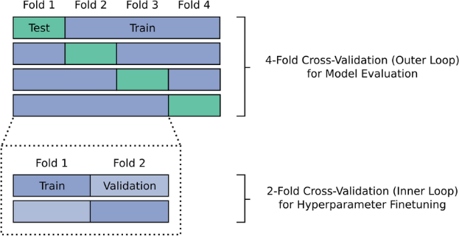
Source: Horst et al. (2023).
The additional advantage of the nCV, which is also one of the main reasons why it’s being used in this thesis, is the ability to choose the best ML algorithm as well. By including multiple algorithms, the value for cross-validated accuracy (averaged over folds) is provided for each of them, and is thus comparable across different ML algorithms. This way, it can be decided which of the various algorithms is most likely to provide the best performance for the classification task at hand. However, it is still advisable to, once the algorithm with the highest cross-validated accuracy is determined, still conduct additional k-fold cross-validations (now non-nested) for the winning algorithm for each of its hyperparameter value options in order to avoid statistical artefacts or having the best model be a result of chance (Berrar, 2025).

4 DEVELOPMENT OF THE ML MODEL FOR THE FOOTBALL MATCHES’ OUTCOME PREDICTIONS
After the in-depth description of the theoretical part of the thesis, the fourth chapter represents the beginning of the practical part of the ML model development. As it is customary, the process starts with the description of how the data was collected and compiled into the database that will serve as the basis for further analyses. Here, the history of the Slovenian First League is briefly explained, alongside its general characteristics, then the literature review (for the features relevant for the prediction of the football matches’ outcomes) is presented, and the sources for the data collected are provided. Next, the preprocessing steps that have been followed through are explained, including the cleaning of the data, standardizing/scaling, feature engineering of the label “Outcome”, as well as the training/test split of the data. Additionally, the multicollinearity analysis that has been conducted is presented, as well as the explanation of how it was used in combination with the empirical research and personal domain expertise, for the purposes of the feature selection. What followed in the process was the development of the nested cross-validations, which is why the next section of the chapter dealt with the hyperparameters for the four algorithms, which ones were included in the procedure and which values were chosen for them. Afterwards, the results of the three nested cross-validations for the three main outcomes (1/X/2) were presented, and in the following section they were analyzed and interpreted in detail. The entire chapter serves as a preparation phase before the development of the main models that served as the basis for the betting odds’ compiling, which is going to be presented in the next chapter.

4.1 Collection and Compilation of Historical Match Data and Model Features
The Slovenian First League (or “Prva Liga”, as it is known locally) is a fairly young national competition, having been founded in 1991 after the country proclaimed its independency. Still, in a short period of time, it has managed to change its format numerous times, optimizing the experience for both the clubs and the fans of the sport alike. To that extent, it consisted of 21 clubs in its inaugural season, changing to the golden standard of the European leagues in the form of double round-robin with 16 clubs in the period of 1993-1995, and then dabbling in an unorthodox system of triple round-robin with 12 clubs for the period of 1998-2003. After having experimented with the formats for a bit more, it has settled on the quadruple round-robin with 10 clubs, having each club play 4 times against all of its opponents (2 times as a host on the home ground and two times as a guest on the away ground). This system, that is currently in place as well, has been active since the year 2005, or to be more precise, since the football season of 2005/06. The system follows all of the other standardized rules of the European leagues as well, in regards to the relegation/promotion circumstances, points delegations and ranking tie-breakings. Due to the stability of the format since 2005, as well as the unpredictability of the quadruple round-robin format with noticeably fewer clubs than most of the other European leagues, the data for the purposes of this master thesis has been collected for the period since the mentioned season of 2005/06 until the most recent season at the time of writing, that being the 2023/24. In other words, the previous 18 seasons of the Slovenian First League have been used as a basis for predicting the outcomes of the most recent 2023/24 season. While it exceeds the customary 80:20 ratio of the training and test data sets, the intention is to overcome the unique circumstances surrounding this national league in comparison to the other European leagues. The data was obtained from two sources: the website transfermarkt.de, for both general and financial club characteristics and regarding the clubs' forms (success in the last five games played for each fixture), and the worldfootball.net website for the rest of the data.
The selection of the features that could prove to be relevant to the prediction of football matches’ outcomes was based on the extensive research of scientific articles with similar research questions to this thesis, personal domain expertise and the constraints of availability. The process began with the literature research, focusing on the articles that used any machine learning technique for the purposes of match outcome prediction. With that in mind, dozens of articles were found that conducted a similar methodology on various other leagues – for example: English/Premier league (Baboota & Kaur, 2019; Goddard & Asimakopoulos, 2004; Rodrigues & Pinto, 2022), Dutch/Eredivisie (Tax & Joustra, 2015), Belgian/Jupiler (Geurkink et al, 2021), Greek Super League (Malamatinos et al, 2022), as well as some articles that covered dozens of European and worldwide leagues in general (Hubáček et al, 2019; Tsokos et al, 2019). Notably, no article was found in regards to the Slovenian First League. The results of the articles have confirmed the relevance of some of the features, such as: the win/draw/loss results (Tax & Joustra, 2015); the amount of goals scored/conceded and the derived goal difference (Baboota & Kaur, 2019; Tax & Joustra, 2015); the success of the home team at home games and of the away team at away games specifically (Baboota & Kaur, 2019; Goddard & Asimakopoulos, 2004); the form of the club reflected by its success in the last five games played (Baboota & Kaur, 2019; Hubáček et al, 2019); the club's budget during the season (Tax & Joustra, 2015). These findings were complemented by personal expertise with the topic at hand, adding onto the number of features for the model.
However, given the lower popularity of the Slovenian First League, the free-of-charge data available was significantly poorer and more restricting compared to the majority of the other European leagues, leading to the unavailability of the more in-depth variables that were in-play or match-specific (e.g. number of shots on/off target, corners, fouls given/received, cards given/received, possession, offsides, injuries, head-to-head form...). Taking that into account, the final list consisted of 62 features – 6 sets of 7 indicators of season success and 2 sets of 10 team characteristics. For the indicators of season success, the features were aggregated across the particular season from the beginning until the match at hand being played, and consisted of: number of wins, number of draws, number of losses, amount of points achieved, amount of goals scored, amount of goals conceded, the goal difference. These were collected for 6 different scenarios: home team's overall season success, away team's overall season success, home team's season success at home games only, away team's season success at away games only, home team's form/success regarding the last five games, away team's form/success regarding the last five games. Additionally, the team characteristics were taken into account, which consisted of: average age of the players, number of arrivals before the start of the season, number of departures before the start of the season, number of foreigners in the team, fair play points – as well as some features that focused on the financial aspect of the clubs, such as: total market value, average market value, income before the start of the season, expenditures before the start of the season, achieved profit before the start of the season. The full list of the features can be seen in the Appendix 2a and 2b.

4.2 Preprocessing Steps (e.g., Cleaning, Feature Selection, Scaling)
Once the database was created with data for the last 19 seasons (or 3420 games) of the Slovenian First League, it was necessary to conduct a bit of cleaning before going forward with the analyses. The financial variables were obtained in the shorthand format using “k” as an abbreviation for thousands and “m” as an abbreviation for million, which was converted to the full numeric values. Additionally, there were instances where the profit, or the balance of the club’s account, was equal to zero, either due to the incomes being equal to the expenditures before the start of the season, or more often due to the lack of any incomes or expenditures due to the club not buying or selling any players (that weren’t free transfers) before the season. In these cases, the data was originally displayed as “-“, to indicate the lack of positive or negative fluctuations in the club’s account, which was converted to its actual meaning of 0 euros for the purposes of later analyses. Similarly, there were instances where the value would be equal to 0 in whichever context, however it was displayed as a blank space to indicate the general lack of the amount for the feature (e.g. data for the first weeks), and in these cases these values were also converted to their intended value of 0.
Lastly, for the fair play points, for the first 3 seasons chronologically (2005/06–2007/08), there was no data available for the clubs that were promoted from the second division before the start of the following season. As including the feature was to establish whether the higher or lower amount of points/fair play could serve as a predictor for the outcome of matches, the missing values for the two clubs (that were promoted for each of the mentioned three seasons) were imputed by calculating the mean of the rest of the teams’ fair play points for the particular season at hand. Nonetheless, given that the data was obtained from the official sources that demand clarity and thoroughness of its data, there wasn’t much of a need for the data cleaning in general. Additionally, due to the nature of the data being the historical records of the clubs’ performances, there was no room for any form of outliers to be present either.
There was a need, however, for a bit of feature engineering, in the form of the creation of the label variables for the future models. In order to cover all of the possible outcomes of the matches (win, draw, loss), three models were developed with binary classifications of: home team won / home team didn’t win (where the label value 0 corresponded to the bet “1”); the match ended in draw / the match didn’t end in draw (where the label value 0 corresponded to the bet “X”); the away team won / the away team didn’t win (where the label value 0 corresponded to the bet “2”). The entire procedure that followed on the case of one of the models (e.g. bet “1”) was replicated in the identical manner for the rest of the models (e.g. bets “X” and “2”).
Having both the label “Outcome” created and the features intended to serve as predictors for it cleaned and prepared, it was possible now to split the data into training and test datasets. Given the nature of the task at hand, which was to have the previous 18 years serve as basis, or now training dataset, for the prediction of the last season at the time of writing, or test dataset, the usual randomized split was not conducted. Instead, the data for the features for the first 18 seasons represented the “X_train” dataset, the data for the label variable for those 18 seasons represented the “y_train” dataset, and correspondingly the data for the features for the last, or 2023/24 season, represented the “X_test” dataset while the data for the label variable for the 2023/24 season represented the “y_test” dataset.
In order to continue with the preparation of data for analyses, it was necessary, as expected, to conduct scaling, or in other words to standardize the data. This was especially evident in the comparison of the financial features to the rest of the features from the list, given the vast differences in range and variance between them. The label “Outcome” which was, as was previously indicated, in a binary form of 0s and 1s, was, of course, not included in the standardization process.
Once the data was successfully standardized, indicated by the values of 1 for the standard deviation and the values extremely close to 0 for the arithmetic means of the features, the next most important step of the data preparation was the multicollinearity analysis. As it can be seen in the figure 20 below, there were certain clusters of features that correlated way too highly with each other, leading to the multicollinearity issues.

Figure 20: Correlation matrix for the initial 62 features
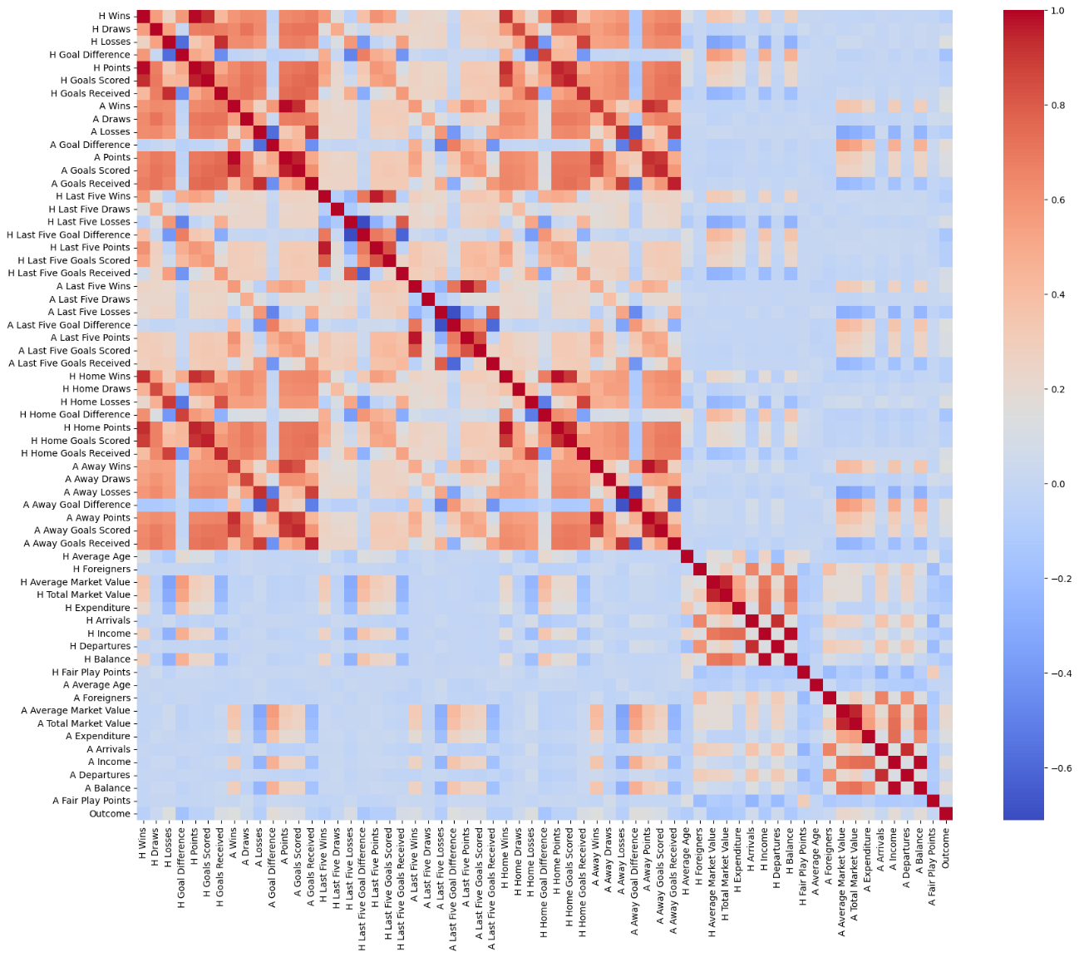
Source: Own work.
Given that there was a high number of 62 features in the initial list of features for the models, and that the specific nature of most of the features was that they were in some way a derivative or a complementary of some other features in the database, frequent and high levels of correlations were expected to occur, and have, in fact, occurred. Some particular examples for why these high correlations were to be expected were features such as: Points, which is calculated as 3*Wins + 1*Draws + 0*Losses; Goal Difference, which is calculated as Goals Scored – Goals Received; and Balance, which is calculated as Income – Expenditure.
The rule of parsimony states that it is recommended to keep the smaller number of features in the model if it conveys the same or similar amount of information value and thus make the model simpler while still retaining the predictive value. In the spirit of this rule, the features that were constituents in the previously mentioned “formulas” were eliminated for all of the scenarios in which they were available, with an exception of Wins and Losses which were kept in place of Points due to the empirical evidence and personal opinion that they carry more informational value than the feature Points itself. In other words, the features Points, Goals Scored, Goals Received, Income, Expenditure were eliminated in all of their available forms (overall, home/away specific, last five form, financial).
While this already reduced the number of features from the initial 62 to 40 (6 scenarios for the first three features and 2 scenarios for the two financial features mentioned beforehand), in order to ensure that the multicollinearity issue was resolved, the variance inflation factor (VIF) values were calculated both before the actual elimination of the redundant 22 features (to confirm that they indeed represent the issue in the dataset) as well as after their removal. The VIF values have shown that there is further trimming needed to be done, as the feature Draws’ VIF was way too high still, and the pair of Arrivals and Departures on one hand, and Average Market Value and Total Market Value on the other, were way too correlated. In order to avoid the redundancy and lower the multicollinearity, all of the Draws features were removes, as well as the Departures and Average Market Value features, as the impression is that their counterparts ought to carry more informational value for the model.
Additionally, the scenarios of data for home teams specific to their success at home games only, and for away teams specific to their success at away games only, were entirely way too correlated with the overall success of the teams across the season, which is why these specific scenarios were removed as well. This resulted in the final list of the 24 features remaining for further analyses. The correlation and multicollinearity analyses were repeated for this final set, and the correlation matrix can be seen in the figure 21 below.

Figure 21: Correlation Matrix for the final set of 24 features
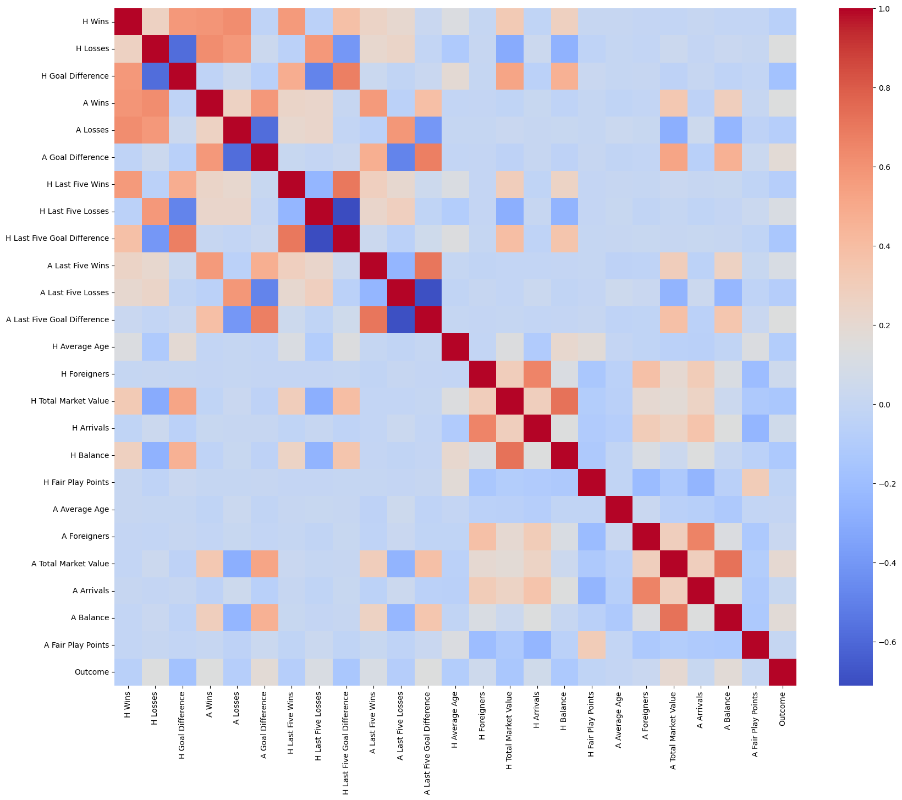
Source: Own work.
When it comes to the VIF values for the remaining features, there were no more “infinity” values as was the case in the previous instances, and instead most of the values were low enough to not warrant any concern at all. It should be noted that several of them, namely H Wins, H Losses, H Goal Difference, A Wins, A Losses, A Goal Difference, contained VIF values ranging from 13 to 15 which exceed the recommended threshold of 10, however this was allowed since it was a conscious decision to keep the Wins and Losses features (which are also the reason for Goal Difference VIF values) instead of Points features due to their expected predictive values for the models. With multicollinearity issue resolved and used as the basis for the feature selection, the model development phase was ready to be conducted.

4.3 ML Model Development and Hyperparameter Tuning
The phase of the model development has been split into two parts: first, the nested cross-validation was conducted in order to compare how the various algorithms fare on the dataset, and then the winning algorithm was once again put through the k-fold cross-validation in order to generate the actual odds. For the purposes of the first part, the nested cross-validation included the four previously described algorithms: logistic regression, support vector machine, gradient boosted trees and XGBoost.
For the first algorithm, the logistic regression, two hyperparameters were taken into consideration: c and penalty, both relevant for the prevention of overfitting. The overfitting represents the scenario where the model’s complexity is too high and thus it gets accustomed to the training dataset to such extent that it fails to generalize when it comes to the new data from the test dataset. In order to prevent this, the regularization technique (as explained when the difference between the GBT and the XGB was described) introduces penalty terms to the loss function, thus lowering the complexity of the model and its fitting to the training dataset. To that extent, the c hyperparameter describes the strength of the regularization technique implemented, where smaller values indicate stronger regularization, leading to simpler models, and vice versa. In order to capture a wider range of regularization strength, the values used for the c hyperparameter were [0.01, 0.1, 1, 10, 100]. Additionally, there are various types of regularization available, such as LASSO (Least Absolute Shrinkage and Selection Operator) or l1 type which adds a penalty term equal to the absolute value of the coefficients, and Ridge or l2 type which adds a penalty term equal to the square value of the coefficients. The l1 type often results in the coefficients being reduced to zero and thus removing the features with low contribution, while the l2 lowers the coefficients close to (but not exactly to) zero and thus preserves the initial set of features for the model. Since the l1 type is more recommended for the feature selection purposes which was already done via multicollinearity analysis and personal expertise, while the l2 on the other hand is more recommended for the prevention of overfitting in general and wouldn't impact the list of features, the l2 or Ridge type of regularization was chosen for the logistic regression.
When it comes to the second algorithm, the support vector machine, three hyperparameters were taken into consideration: c, gamma and kernel. The c hyperparameter is quite similar to the one used for the logistic regression, as it also indicates the strength of regularization being applied. In the case of SVM, it particularly corresponds to the width of the margin between the support vectors, with higher c values indicating narrower margins and could lead to the higher possibility of overfitting, while the smaller c values indicate wider margins which reduce the probability of overfitting but could lead to higher possibilities of misclassification. The same values of [0.01, 0.1, 1, 10, 100] were covered in this case as well. The gamma hyperparameter deals with the clusters of data, or the convex hulls and their boundaries. The higher the values of the gamma, the higher are tendencies for the boundaries of the clusters to get as close to the cluster members as possible, leading to irregular shapes of the boundary and higher chances of overfitting. Inversely, the smaller the values of the gamma hyperparameter, the boundaries of the clusters tend more to be wider and smoother, lowering the chances of overfitting, but leading to higher possibilities of misclassifications during the generalization to new data. The two customary options for gamma include auto and scale. The auto option is equal to 1/(number of features), focusing on the dimensionality on the data, and usually corresponds to the higher values of gamma. The scale option takes into account the variability of the data as well, being equal to 1/(number of features *variance of the features), which makes it more robust and leads to the smaller values of gamma. Both of these options were used for the hyperparameter tuning. Lastly, the kernel function of the SVM relates to the shape of the data, and to the approach to creating the optimal hyperplane. As it was described previously, the two data clusters corresponding to the two binary outcomes of the label variable could be completely linearly separable, in which case the linear option for the kernel is used. But, it was noted that there is a realistic probability that the linear separability might not be the case and that the hyperplane might have to resemble a radial line from the two-dimensional perspective of the data, in which case the rbf option is used, standing for “radial basis function”. To cover both of these possibilities, both of the options were used.
The third algorithm, the gradient boosted trees, got three hyperparameters covered in the nested cross-validation: n_estimators, learning rate and max_depth. The first one, the n_estimators, indicates the number of trees that are going to be sequentially added in the model following the initial classifier. As it can be expected, the higher number of trees (or estimators) leads to more opportunities for the model to improve upon itself, but also increases the chances of overfitting. Too small number of the estimators, however, might not be enough for the model to reach its optimal capability for classifying the data at hand. Since the value needs to be somewhere in-between, the options chosen for the n_estimators were [50, 100, 150], taking into account the fact that too many trees might not only lead to overfitting but are also computationally very costly, and the nested cross-validation is already a pretty costly procedure in itself. The learning rate corresponds to the previously described hyperparameter ρ, denoting the size of the incremental steps taken towards the minima of the loss function with each new tree sequentially added to the model. Lower values of the learning rate require more trees in order to be able to reach the minima, but also increase the chances of overfitting and computationally have a high cost. The values chosen were [0.01, 0.1, 0.2]. The third hyperparameter, the max_depth, as its name suggests, corresponds to the depth of the individual trees in the model. The higher the value of depth, the model will have more opportunities to learn and optimize itself – however, it will also have higher probabilities for overfitting, lowering the success of generalization. With that in mind, and with the number of trees going to 150 in one of the scenarios for the n_estimators, the values for max_depth were chosen as [3, 5, 7], considering not only the risk of overfitting, but the computational cost once again as well.
The final algorithm in the procedure, the XGBoost, is in theory an improved version of the boosting classifiers such as gradient boosted trees, which is why its hyperparameters are largely the same – n_estimators, learning rate and max_depth. Accordingly, identical values have been used, meaning – for n_estimators [50, 100, 150], for learning rate [0.01, 0.1, 0.2] and for max_depth [3, 5, 7]. The XGBoost, as an improved version, however, offers an additional hyperparameter gamma. Since the lower depths of the trees are usually recommended to avoid overfitting and higher computational costs, it should also be noted that trees that are too shallow might not contribute significantly to the model overall. To combat this and balance the contributions, the value of the gamma hyperparameter represents the threshold for further splitting of the trees into more nodes. In other words, it sets a minimum loss reduction that is required to be achieved in order for the trees to split further by adding nodes, thus once again controlling overfitting and reducing the complexity of the model. To this extent, the values of [0, 0.1, 0.2] were used, to include the scenario without the threshold as well.

4.4 Model Evaluation Metrics and Performance Assessment
As noted previously, there were 3 different iterations for the model development, in particular for the outcomes 1, X and 2 (or home team won, draw, away team won), leading to 3 instances of nested cross-validations with different label variables beforehand as well. The following are the results of all of the nested cross-validations, which can be seen in the Tables 1–3 below.
Based on these results, which have shown that the highest: accuracy, f1 score and ROC AUC (Receiver Operating Characteristic Area Under the Curve) score almost consistently belong to the logistic regression, this algorithm was chosen as the most adequate one for the task at hand. It should, however, be noted that the variations are very small between the 4 algorithms, with the biggest differences in accuracy amounting to 0.014, in f1 score to 0.013 and in ROC AUC to 0.24 across all three nested cross-validations, indicating that the models were fairly comparable for the task.

Bet 1 (home team won):

Table 1: Nested cross-validation for the betting outcome 1
 | Logistic Regression | Support Vector Machine | Gradient Boosted Trees | XGBoost
mean_accuracy | 0.637 | 0.623 | 0.622 | 0.624
mean_precision | 0.654 | 0.635 | 0.638 | 0.645
mean_recall | 0.785 | 0.815 | 0.793 | 0.773
mean_f1_score | 0.713 | 0.714 | 0.707 | 0.703
mean_roc_auc | 0.671 | 0.658 | 0.647 | 0.655
Source: Own work.

Bet X (draw):

Table 2: Nested cross-validation for the betting outcome X
 | Logistic Regression | Support Vector Machine | Gradient Boosted Trees | XGBoost
mean_accuracy | 0.747 | 0.747 | 0.746 | 0.746
mean_precision | 0.747 | 0.747 | 0.747 | 0.747
mean_recall | 1.000 | 1.000 | 0.998 | 0.998
mean_f1_score | 0.855 | 0.855 | 0.854 | 0.855
mean_roc_auc | 0.490 | 0.511 | 0.492 | 0.496
Source: Own work.

Bet 2 (away team won):

Table 3: Nested cross-validation for the betting outcome 2
 | Logistic Regression | Support Vector Machine | Gradient Boosted Trees | XGBoost
mean_accuracy | 0.696 | 0.689 | 0.685 | 0.692
mean_precision | 0.712 | 0.704 | 0.716 | 0.714
mean_recall | 0.926 | 0.932 | 0.886 | 0.909
mean_f1_score | 0.805 | 0.802 | 0.792 | 0.800
mean_roc_auc | 0.679 | 0.658 | 0.672 | 0.675
Source: Own work.

4.5 Comparative Analysis of the Model Performance Across Algorithms
It can be seen from the Tables 1-3 that the models across all of the parameters have satisfying results overall, however there are small variations that could be further commented on.
In the case of the first model, intended for the betting outcome 1, the accuracies range from 0.622 to 0.637, which is in the vicinity of expectations, given that the previously mentioned empirical findings have stated that the average accuracy for predicting football matches’ outcomes is around 0.65. Both the precisions and recalls are high enough, indicated by the f1 scores ranging from 0.703 to 0.714. These values show that the precisions and recalls are adequately balanced, and that the model is a good binary classificator as well. The ROC AUC scores, which give an insight into discriminative ability of the model, ranges from 0.647 to 0.671, showing adequate discrimination in comparison to the 0.5 threshold which would be equal to random guessing. Across the algorithms, the logistic regression has the highest accuracy, the highest ROC AUC score, and second highest f1 score with only 0.01 difference, which shows that it is the clearest option for further model development and odds compiling. The accuracies of the rest of the three algorithms are almost identical (with gradient boosted trees and XGBoost even more so having noticeably lower f1 scores), and all three of them have showcased noticeably lower ROC AUC values in comparison to the logistic regression (especially in the case of the gradient boosted trees).
The second model, intended for the betting outcome X, is objectively the hardest one to properly classify its cases for numerous reasons. Not only is there the biggest imbalance between the binary label’s number of outcomes, but the features are historically not naturally inclined to predict the outcome of the match as a draw – the team that has an advantage in the areas of wins, goals scored, incomes and higher market values ought to have higher chances of winning, while the team that has more losses, goals conceded, expenditures and lower market values ought to be inclined towards losing. Even empirically, the betting companies have on average placed the probability for the draw outcomes to be consistently around 25%, which converted to the decimal format of betting odds equals to the value of around 4.00. This can also be noticed in the inspection of the odds from the two betting companies that will later on be used for the profitability analysis, whose odds across the entire season of 180 matches range only from 3.50 to 4.50 for the draw outcome, with little exceptions at that. All of this is also reflected in the results obtained for the nested cross-validation for this outcome. Even though the accuracies are even higher than beforehand, equaling to either 0.746 or 0.747, this, however, is a false image of the success of the model’s classification. This can be noticed in the unusually high recall rate equaling 1, indicating that there are no false negatives. And, indeed, there are no false negatives in the model, because, as it will be shown in the confusion matrix in the next chapter, all of the 180 cases were classified as an outcome “1”, or in other words “not a draw”. This means that there are no false negatives, however, it also means that there are no true positives as well, as 46 games that actually ended in a draw were all classified as “not a draw”, and the remaining134 games that didn’t end in a draw were successfully all classified as “not a draw” outcome. The unsuccessful classification is also apparent in the ROC AUC scores which range from 0.490 to 0.511, not being able to surpass the threshold of random guessing of 0.500 in a satisfying manner.
This, however, is the same result that happens when analyzing the historical bets of two of the mentioned betting companies that will be used for the profitability analysis later on – for their publicly available bets that range from 3.50 to 4.50 as it was already stated, the confusion matrix look the same, with all of the 180 matches classified as “not a draw” outcome due to the probabilities being consistently less than 50% (or above the decimal odd of 2.00) across the entire season. As it will also be seen later on, nonetheless, this issue with the “draw” outcome actually does not represent the problem for the betting companies in real life, as the betting odds that are conservatively established at consistent probabilities of around 25% per each match, still lead to certain amounts of profits for the companies – as is the case for both my generated odds and the odds generated by the two leading betting companies in the Europe. Thus, the classification metrics are actually not a good indicator of the success of the model for this outcome of X or draw, and instead profitability will serve as a much more suited analysis in this case.
The third model is more akin to the first one, now dealing with the outcome of the away team winning, or the betting outcome of 2, and hence the model evaluation metrics make more sense and are actually useful in comparison to the previous model for the X outcome. Here, the accuracies even exceed the empirical average of 0.650 by ranging from 0.685 to 0.696 across all of the algorithms. Not to base the success of the classification task solely on the accuracy, of course, the rest of the metrics are once again taken into consideration, especially the f1 score and the ROC AUC score. The f1 scores are also even higher than in the first model, ranging from 0.792 to 0.805, which is considered a good f1 score in general. The ROC AUC scores are similar to the first model, ranging from 0.658 to 0.679, once again indicating a satisfactory discrimination of the model. With all of the algorithms being successful at the task, it is once again evident that the logistic regression is the optimal choice, as it resulted in the highest accuracy, f1 score and ROC AUC score in comparison to the rest of the algorithms. What can also be noticed is that the gradient boosted trees as an algorithm shows the lowest scores for accuracy and f1 in comparison to the others, while the support vector machine shows the lowest ROC AUC score. On the other hand, XGBoost’s result are very similar to the logistic regression’s, being slightly weaker for all of the parameters analyzed.

5 RESULTS
The preliminary phases for the model development have been concluded, and in this chapter the main focus is on the actual machine learning algorithm being used for the compiling of the betting odds, as well as assessing the success of such endeavor. To that extent, it is first explained how the models were developed with the chosen algorithm for all of the outcomes, with the hyperparameters tuning once again in mind. The models’ performance was assessed using accuracy as a metric. In order to complement the accuracies achieved, the confusion matrices are also presented, so they could provide a clearer picture into the models’ classification success. The odds that were generated from these models for the three main outcomes in football matches (home team won / draw / away team won), were presented side-by-side with the odds publicly provided by the two leading betting companies that were already mentioned beforehand. In order to gain a better insight into the comparison between the three sets of odds, and the overall quality of the odds generated by the machine learning models, the accuracies and confusion matrices for all three sets of odds were also presented side-by-side. Since accuracy as a metric is not the most adequate one for the domain of the sports betting, the main evaluation of the odds is done in the form of the profitability analysis, providing the simulated profits and ROIs that the odds could generate for the given season of 2023/24 of the Slovenian national league.

5.1 Generating the Betting Odds
As the logistic regression had proven to be the optimal model for the classification task of the football matches’ outcome prediction, it has been chosen for the next stage of the betting odds compiling. After a nested cross-validation compared the algorithms and one came out on top, it was advisable to conduct an additional non-nested k-fold cross-validation solely for the “top” algorithm. Thus, the 3 k-fold cross-validations for logistic regression have been independently conducted for the three outcomes (1/X/2). Multiple hyperparameters were once again taken into consideration, with the same choices being made as for the nested cross-validations – c hyperparameter with the values of [0.01, 0.1, 1, 10, 100] and model_penalty regularization type hyperparameter of l2 or Ridge. The different options for the hyperparameters, however, didn’t result in any differences as it seems that the models have reached their optimal state regardless of the changes in the c values. The mean accuracies for the three models performed on the training datasets can be seen in the Table 4 below.

Table 4: Accuracies of cross-validated logistic regressions on training datasets
 | Outcome 1 | Outcome X | Outcome 2
Mean Accuracy | 0.630 ± 0.037 | 0.746 ± 0.003 | 0.695 ± 0.024
Source: Own work.
Once the models were trained, they were used to predict the outcomes for the test sets. Their accuracies and confusion matrices are presented below. The accuracies can be seen in the Table 5, and are not too far off from the values that were obtained on the training datasets, indicating the absence of the overfitting issues.

Table 5: Accuracies of cross-validated logistic regressions on test datasets
 | Outcome 1 | Outcome X | Outcome 2
Mean Accuracy | 0.733 | 0.744 | 0.656
Source: Own work.
The confusion matrices provide a bit more insight into the classification successes of the models in the Tables 6–8 below (TP and TN stand for “true positives” and “true negatives”, PP and PN stand for “predicted positives” and “predicted negatives”).
Table 6: Confusion Matrix for the outcome 1  PP PN  TP 38 32  TN 16 94 | Table 7: Confusion Matrix for the outcome X  PP PN  TP 0 46  TN 0 134 | Table 8: Confusion Matrix for the outcome 2  PP PN  TP 19 45  TN 17 99
Source: Own work.
As it can be seen from the confusion matrices, there was an imbalance present in the test dataset which affected the success of the classification tasks. However, as it was already noted, the actual classifications into the categories was not that much of the main focus of the thesis, which is especially apparent in the case of the X outcome. Instead, the calculation of the probabilities for each of the 180 events and their subsequent conversion into the betting odds takes the role of the primary concern. While it might seem contraindicative at first, the empirical facts are: that the probabilities for the outcome X is consistently less than 50% in betting companies; in general, the betting odds in football work in such a way that, for the same event, the odds for the three possible outcomes (1/X/2) do not aggregate to 100% as the sum of probabilities; since the home team and away team can both have the odds corresponding to the probabilities of less than 50% for the same event (both teams having the odds’ value above 2.00), that event is bound to be misclassified in all of the models developed for it for all of the outcomes, leading to not only misclassifications for the outcome X but for the outcomes 1 and 2 as well. With this being said, the above results do not discourage from the future successes of the betting odds compiling, and thus, the odds’ generating was the next step.
The probabilities were calculated for each of the models’ label outcome 0 which corresponded to the outcomes 1/X/2 for each model respectively. The probabilities for the models’ label outcome 1 were also calculated, however they serve no purpose in this thesis, as they would actually be indicative of the probabilities for the betting outcomes of the so-called double chances X2/12/1X for each model respectively (and this thesis does not cover these additional betting odds outcomes). What was also an important addition to the process is the inclusion of the bookie’s margin, a term which stands for the calibration of the realistic odds (or probabilities) of the events by the betting companies, in order to assure a certain amount of profits to their advantage. There are variations across the approaches of including the margin, as each of the betting companies differently deals with this topic, and the individual approaches are almost universally kept as a “secret recipe” for each of the companies. What is also known is that the online bookies actually adjust the odds dynamically from the moment they provide the odds until the moment of the start of the event, based on the number of bets placed on certain outcomes, which also skews the realistic probabilities of the betting outcomes for the bettors. To this extent, for the purposes of this thesis, it was chosen to approach the matter by applying the flat-betting margin of 5% – in other words, the constant of 5% margin was added onto the odds compiled for all of the events. The example of the created odds can be seen in the Figure 22 below for the fixture 1 of the season 2023/24, and for comparison purposes the odds by the betting companies 1Xbet and William Hill for the same events can be seen in the Tables 23 and 24 that follow.

Figure 22: Example of the bookie's betting list with odds compiled for the week 1 of the season 2023/24
Slovenia 1 |  |  |  |  | Betting Outcome
Day | Time | Event Code |  |  | 1 | X | 2
Betting Code |  |  |  |  | 01 | 00 | 02
Sat | 16:30 | 1 | NK Bravo | NK Rogaška | 1.89 | 3.06 | 3.07
Sat | 16:30 | 2 | NŠ Mura | NK Domžale | 2.25 | 2.51 | 2.37
Sat | 19:15 | 3 | FC Koper | Olimpija Ljubljana | 3.90 | 3.40 | 1.93
Sun | 16:30 | 4 | NK Radomlje | NK Maribor | 4.12 | 2.80 | 1.49
Sun | 19:15 | 5 | NK Aluminij | NK Celje | 3.99 | 3.54 | 1.77
Source: Own work.

Figure 23: Example of the bookie's list with the betting odds from 1XBet for the week 1 of the season 2023/24
Slovenia 1 |  |  |  |  | Betting Outcome
Day | Time | Event Code |  |  | 1 | X | 2
Betting Code |  |  |  |  | 01 | 00 | 02
Sat | 16:30 | 1 | NK Bravo | NK Rogaška | 2.00 | 3.18 | 4.10
Sat | 16:30 | 2 | NŠ Mura | NK Domžale | 1.89 | 3.50 | 4.12
Sat | 19:15 | 3 | FC Koper | Olimpija Ljubljana | 3.40 | 3.40 | 2.13
Sun | 16:30 | 4 | NK Radomlje | NK Maribor | 4.90 | 4.05 | 1.65
Sun | 19:15 | 5 | NK Aluminij | NK Celje | 4.25 | 3.85 | 1.75
Source: Own work.

Figure 24: Example of the bookie's list with the betting odds from William Hill for the week 1 of the season 2023/24
Slovenia 1 |  |  |  |  | Betting Outcome
Day | Time | Event Code |  |  | 1 | X | 2
Betting Code |  |  |  |  | 01 | 00 | 02
Sat | 16:30 | 1 | NK Bravo | NK Rogaška | 1.95 | 3.10 | 3.60
Sat | 16:30 | 2 | NŠ Mura | NK Domžale | 1.85 | 3.30 | 3.70
Sat | 19:15 | 3 | FC Koper | Olimpija Ljubljana | 3.10 | 3.10 | 2.15
Sun | 16:30 | 4 | NK Radomlje | NK Maribor | 5.00 | 3.60 | 1.57
Sun | 19:15 | 5 | NK Aluminij | NK Celje | 4.00 | 3.50 | 1.73
Source: Own work.

5.2 Evaluation of the Odds’ Accuracy and Profitability
The betting odds have been compiled, and in order to establish the success of using machine learning algorithms for their generating on the case of the Slovenian First League, the accuracies, confusion matrices and profitabilities were analyzed for the generated odds as well as for the available odds from the two betting companies:1XBet and William Hill. The accuracies for the three sets of odds can be seen in the Tables 9–11 below. The results show that the more conservative approach of the flat 5% margin might lead to a bit more realistic probabilities for the events (except for the outcome 2), especially since the bets for the two betting companies were affected by the dynamic calibration based on the frequency of bets placed on the outcomes.

Table 9: Accuracies of the odds for the outcome 1
 | Generated Odds | 1XBet | William Hill
Odds’ Accuracy | 0.722 | 0.690 | 0.710
Source: Own work.

Table 10: Accuracies of the odds for the outcome X
 | Generated Odds | 1XBet | William Hill
Odds’ Accuracy | 0.744 | 0.740 | 0.740
Source: Own work.

Table 11: Accuracies of the odds for the outcome 2
 | Generated Odds | 1XBet | William Hill
Odds’ Accuracy | 0.644 | 0.660 | 0.660
Source: Own work.
The confusion matrices for the comparison of the classification success can be seen in the Tables 12–14 below. The results show that: for the outcome 1, the odds from 1XBet and William Hill have slightly better classification of the cases for the label outcome 0 (or “true positives”) in comparison to the generated odds, while they have slightly lesser successes when it comes to the label outcome 1 (or ” true negatives”); for the outcome X, as it was already stated several times, the classification matrix and overall accuracy is not a suitable indicator and the profitability analysis later on will show different results to those present here; for the outcome 2 it seems to be an inverse situation in comparison to the outcome 1, since now the odds from 1XBet and William Hill have slightly worse classification when it comes to the “true positives” while having a slightly better success when it comes to the “true negatives”. Upon a closer look at the generated odds in particular, it can be seen that the classification was much more successful for the cases of the “true negative” being classified correctly in comparison to the “true positives”. Imbalance in the dataset, as well as the overall low probabilities of the individual outcomes occurring are the main reasons behind such results. Additionally, when it comes to the more relevant classification of the “true positives”, it can be seen that: for the outcome 1, the generated odds accurately classified 61.43% of the events pertaining to the events resulting in the said outcome; for the outcome X there were no accurately classified cases as the threshold of 50% chances of the outcome occurring was not reached for any event across the entire season; for the outcome 2, the generated odds accurately classified 37.5% of the cases in which the said outcome did historically occur.

Table 12: Comparison of the confusion matrices for the outcome 1
Generated Odds  PP PN  TP 43 27  TN 23 87 | 1XBet  PP PN  TP 44 26  TN 29 81 | William Hill  PP PN  TP 46 24  TN 29 81
Source: Own work.

Table 13: Comparison of the confusion matrices for the outcome X
Generated Odds  PP PN  TP 0 46  TN 0 134 | 1XBet  PP PN  TP 0 46  TN 0 134 | William Hill  PP PN  TP 0 46  TN 0 134
Source: Own work.

Table 14: Comparison of the confusion matrices for the outcome 2
Generated Odds  PP PN  TP 24 40  TN 24 92 | 1XBet  PP PN  TP 21 43  TN 18 98 | William Hill  PP PN  TP 23 41  TN 20 96
Source: Own work.
The profitability analysis, perhaps the most relevant factor for the betting companies and their business’ successes, was conducted in the following way: for each of the 180 matches in the season, the stakes placed on each game amounted to €10, and the bettor has placed all of the 180 bets on the relevant outcome for the scenario. In other words, in the first scenario (outcome 1), the bettor has placed bets on all 180 games on the outcome of the home team winning for all three sets of the odds relating to the said outcome. The similar process was repeated for the outcomes X and 2, with the bettor placing 180 bets for the outcome X for all three sets of odds separately, and 180 bets for the outcome 2 for all three sets of odds separately. The results of the profitability analysis can be seen in the Tables 15–17 below. The results show that: for the outcome 1, all three sets of odds have generated profit with ROI ranging from 15.56%–21.57%, with both 1XBet and William Hill garnering higher profits in comparison to the generated odds; for the outcome X, while all three sets have achieved positive profits, the generated odds have accrued significantly larger profits, evident by the ROI being 3–4 times the amount of the betting companies’ ones; for the outcome 2, the 1XBet company actually suffered a loss (even though the amount is relatively small), while the William Hill company achieved a modest profit and the generated odds have once again stood out with noticeably higher amount of profit and therefore the ROI percentage.

Table 15: Profitability analysis for the outcome 1
 | Generated Odds | 1XBet | William Hill
Profit | €280.00 | €311.20 | €388.20
ROI | 15.56% | 17.29% | 21.57%
Source: Own work.

Table 16: Profitability analysis for the outcome X
 | Generated Odds | 1XBet | William Hill
Profit | €355.10 | €78.50 | €124.20
ROI | 19.73% | 4.36% | 6.90%
Source: Own work.

Table 17: Profitability analysis for the outcome 2
 | Generated Odds | 1XBet | William Hill
Profit | €266.50 | - €18.90 | €41.90
ROI | 14.81% | -1.05% | 2.33%
Source: Own work.

These results are, evidently, the consequence of the betting companies’ dynamic and extreme calibrations of the margins for the odds, as there were even odds reaching the value of 11.00, which would correspond to the probability of 0.091% – a probability that is empirically almost completely unrealistic for any outcome of the match. In cases where the outcomes with such inflated odds have actually came to fruition, these companies ended up paying out much more drastic amounts of money, given that the payout is equal to the odds multiplied by the stakes invested.

6 DISCUSSION
The focal results of the accuracy and profitability analyses are presented in-depth here in order to further understand them, as they would serve as a basis for reaching conclusions regarding the thesis’ goals. Additionally, there were certain limitations relevant to the outcomes of the research, which were explained in the terms of how they came to be and what could their repercussions possibly be, from the speculative point of view. Suggestions for future research on the topic, especially in the context of the Slovenian First League, on how to overcome the said limitations are also provided, in hopes of encouraging more works similar to this one. At the end of the chapter, there is a very relevant and necessary reminder of the dangers and the possible effects of the betting and gambling activities in general. Ways to recognize the issues in oneself or in regards to the loved ones are listed, alongside the tips and advices for responsible betting practices.

6.1 Presentation of the Main Findings
The purpose of this thesis was to assess the usability of ML algorithms for the purposes of compiling betting odds, with a special focus on a football league whose circumstances are less opportune in comparison to the more popular and researched ones in Europe (for example, the Big 5 – English, Spanish, Italian, German, French). The goals of the thesis, as previously presented, were as follows:
  - to design and implement an ML-based model for predicting the outcomes of football matches in the Slovenian first league by utilizing the nested cross-validation;
  - to calculate the betting odds for the Slovenian first league’s matches;
  - to evaluate the predictive performance of calculated betting odds for the Slovenian first league’s matches and compare it to the competitors’ odds on the market;
  - to evaluate the profitability of calculated betting odds for the Slovenian first league’s matches in comparison to the odds provided by competitors on the market.
Once the data was preprocessed and prepared for the analyses, the procedure of nested cross-validation has been commenced. The crucial step of the nCV was the hyperparameter tuning, as part of which the following hyperparameters were taken into consideration: c and penalty (for logistic regression); c, gamma and kernel (for the SVM); n_estimators, learning rate and max_depth (for the GBT); n_estimators, learning rate, max_depth, gamma (for the XGB). The values for the hyperparameters were determined based on the compromise of: empirical recommendations, personal expertise and technical constraints of the available system on which the analyses were conducted. The identical nCV procedure was repeated three times separately for three different Outcome labels (for the “1”, “X” and “2” bets) and all three nCVs successfully managed to design models for predicting the corresponding outcomes of the football matches, accomplishing the first goal of the thesis. Following through with the empirical recommendations for the methodological soundness of the process, the conducted nCVs were further analyzed and have all shown that the logistic regression out of all 4 algorithms was the most suitable one for the task at hand. This was established based on the following parameters: accuracy, precision, recall, f1 score, ROC AUC values, and the parameters have shown that all of the algorithms were comparably able to perform the classification task, with smaller favor consistently going towards the logistic regression.
With nested cross-validations successfully serving as the basis for the ML models for predicting the matches’ outcomes, the next goal was to generate the odds from them. In order to do so, the recommendation obtained from the nCVs was taken, which was to further rely mainly on the logistic regression as the optimal choice for the algorithm. Thus, the non-nested k-fold cross-validations were repeated on it, with the same choice of hyperparameters of c and penalty. These analyses were also successful at the classification task, and have provided their results in the form of probabilities for the individual matches’ outcomes for the entire 2023/24 season. The probabilities were then taken and converted into the European format of decimal odds for each of the 180 matches, successfully calculating the betting odds and accomplishing the second goal of the thesis.
The third goal of the thesis was to evaluate the predictive performance of these generated betting odds. To that extent, the accuracy was chosen as a metric since the designed ML models were essentially performing classification tasks, and as such their successes could be reflected in the percentage of accurately classified outcomes of the recorded events. The models have shown that the accuracies successfully reach the empirical average for the research on the ML’s application for football betting of 65%, accomplishing the third goal of the thesis, with the percentages being as follows: 72.2% for the outcome 1, 74.4% for the outcome X, and 64.4% for the outcome 2. While these numbers look very promising on their own at first glance, it should be noted that the confusion matrices painted a slightly different picture, however. As it was already stated, there are certain peculiarities to the betting odds: they do not adhere to the expectation of having the event’s probabilities for the three possible outcomes aggregate to 100%, often exceeding it mathematically; certain outcomes, such as the draw, consistently have their probabilities around a benchmark of 25% for all the season’s matches, indicating a general low level of occurrence; additionally, the bookie’s margins skew the odds from the original probabilities for the sake of ensuring the profits. As a result, the reality of the models was that they were actually very successful at predicting that the relevant outcomes would not occur (corresponding to label outcome 1, or the “true negatives”) instead of successfully predicting the particular outcomes (label outcome 0, or the “true positives”).
And while the classification success was thus somewhat tarnished, the general success of the ML models for the compiling of betting odds was not affected by this. Since the accuracies as performance metrics may not represent the realistic portrayal of the quality of the odds for this particular domain of business, there is another metric that aids in this task, and is of much greater importance for the betting companies – the profitability of the generated odds at hand. Lucrative businesses as they are, the betting companies offer the betting odds to the bettors that (to an extent) represent the realistic circumstances regarding the sporting events, while primarily keeping in mind the expected profit that their odds will be able to return to them and keep the business afloat. This is why there are special ways of ensuring the profits, such as bookie’s margins that deviate the odds from the real chances of an outcome occurring in favor of achieving higher returns from the bets placed, as well as real-time calibrations of the odds (in the cases of online betting) in response to the amount of bets placed on certain outcomes. With all of this in mind, the fourth goal of the thesis actually represented the focal part of the process, which was to evaluate the profitability of the odds. In order to accomplish it, the profitability analysis was conducted, by simulating a bettor placing their bets on the odds provided by the ML model, with a constant stake for one event per bet for the entire season of 2023/24.
The analysis was not only conducted on the generated odds, which would showcase their profitability on their own, but was also performed on the odds publicly provided by two leading betting companies in Europe, 1XBet and William Hill. The comparison of the generated odds’ profitability with the profitability of the real-life betting companies would provide a much more realistic insight into the success of the utilization of ML algorithms in the world of betting. The profitability analysis ended up showing much more promising results – not only did the generated odds garner profits for each of the outcomes, the ROI (return on investment, calculated here as the ratio of total profit over total stakes for the season) was ranging from 14.8% to 19.7% across all of the outcomes, indicating a satisfying amount of profit for the company, thus accomplishing the fourth and most important goal of the thesis. Additionally, the ROI for the outcomes X and 2 was significantly larger in comparison to the two mentioned betting companies’ odds; and even in the case of the outcome 1, where the ROI for the generated odds was the lowest amongst the three sets of odds, the said ROI still amounted to the satisfactory 15.56%. These results indicate that the odds that were compiled by using the machine learning algorithm were adequate enough to: be comparable to the odds provided by the leading betting companies in Europe, and more importantly, to generate profits and keep the business afloat for the betting companies that choose to rely on this technology.

6.2 Limitations of the Study
Even though the results stemming from the profitability analysis were highly promising, there still were a number of limitations to this study that ought to be taken into consideration. First and foremost, the biggest constraints in the research pertained to the fact that the Slovenian First League is not one of the leagues that enjoys much interest from the bettors and bookies alike, leading to a significant lack of databases available online for free, in comparison to the more covered football leagues (even outside of the Big 5 as well). In fact, none of the databases were readily available for the task at hand, leading to the lengthy scraping of the data from publicly available online sources. This, in turn, lead to the majority of the features (relevant for the task at hand) missing from the research, as they were unavailable without paying to certain providers for the data – which seriously limited the list of features used for the analyses. This might be considered as the biggest limitation of the study, since it is a known fact that, if the data that serves as the input for the machine learning models is not of the highest quality, we can’t expect the output/results to be of the similar quality either.
The second limitation has to do with the computational costs of the nested cross-validations, which require much more powerful systems in order to cover the recommended values for the hyperparameters that are being tuned. In particular, the kernels for the SVM algorithm, as well as all of the hyperparameters for the boosting algorithms (gradient boosted trees and XGBoost), were quite modest when it came to the values that were being covered in the tuning phase of the nested cross-validations. More modest hyperparameters’ ranges for the SVM, gradient boosted trees and XGBoost could’ve been one of the reasons for their poorer performances in comparison to the logistic regression, which had lower number of hyperparameters and, to that extent, the wider range that was covered. This, however, is just one of the possible reasons for the success of the logistic regression algorithm over the other ones, as the task at hand was a binary classification with smaller dataset that was not as complex, and as such is more attuned for the simpler algorithm instead. Nonetheless, it is a limitation that should be addressed in order for the nested cross-validation procedure to reach its full potential (as a basis to choose the optimal ML algorithm for the data and the task at hand).
The third relevant limitation is a result of the professional secrecy in the field of sports betting, especially when it comes to their unique ways of odds compiling and profit assurance. Due to striving not to stray too much from the realistic probabilities for the events’ outcomes, the bookie’s margin used for the generated odds in the thesis was the flat 5% for all of the events; however, it was obvious that the odds from the betting companies used for comparison had much larger margins that differed between the events based on different factors, one of those being the amount of bets placed on an outcome before the event has started. The fixed nature of the margin, alongside its modest value of 5%, could’ve led to a more conservative approach that on the long run would amount to a lesser but more stable profits, which might not necessarily be the desired goal for betting companies. On the level of this thesis, such margin might have affected the results of the comparison between the three sets of odds.
The last limitation of the thesis (after the feature selection constraints) is the unrealistic nature of the simulation for the profitability analysis. Single-event bets are generally rare in the world of European football betting, as there are much higher incentives for creating the so-called tickets with 5, 7 or 9 events grouped for the invested stake. Not only that, but the tickets pretty much always consist of events that are from various different national leagues, and as such, bets that are exclusively placed on the events from a single national league do not represent the actual behavior of the bettors. In other words, the scenario of a single bettor placing bets with equal stakes in an individual manner for all of the events of the entire season of any national league is a simulation that doesn’t hold much weight for the real-world applications. On the other hand, as the thesis consists of the analyses conducted exclusively on the data for the Slovenian First League, there is no leeway for the simulation to be any more realistic, and the main purpose of the simulation was to assess the profitability of the generated odds in comparison to the other competitive odds in a similar setting, and not to simulate the actual experiences of bettors in Europe.

6.3 Suggestions for Future Research and Improvements
With these limitations in mind, there are several suggestions that could be made in order for the future research on the topic to have even more success. First of all, since the Slovenian First League is not as covered as other European leagues (the data thus being significantly more sparse in comparison), the main focus for the researchers interested in this league should be the gathering of the data, and its systematic organization into the functional databases that may serve for the future articles as well. This is the only alternative to paying high amounts of money for the data access, and even then it is possible that multiple different sources might be needed for a comprehensive database for the analyses, leading to high costs for the individual article to be written – not to mention that such practice would not alleviate the exact issue at all for any future articles. Once the data is more publicly available for the researchers, the inclusion of empirically highly relevant features that deal with the in-game statistics is the next necessary step. Such features would most likely be: the offensive quality (shots taken on/off target, number of corners taken, number of offsides made), the defensive quality (number of saves made by the goalkeeper, number of interceptions made by the players), on-field advantage (ball possession percentage, passes made, percentage of successful passes), aggressive play indicators (number of fouls made, yellow/red cards received, number of injuries experienced¸ number of penalties awarded) as well as some other team-based decisions throughout the game (line-ups, substitutions). Some other circumstances might be relevant as well, such as distance traveled for the away games, weather, grass conditions. Additionally, the undoubtedly relevant features would be in relation to the head-to-head stats regarding the clubs previous encounters.
Once the data for the mentioned features can be collected, the following suggestion is to conduct the analyses on a stronger system, one able to process wider ranges for the hyperparameters’ tuning, in order for the more complex algorithms (such as XGBoost, for example), to be able to achieve optimal results.
The limitation that is caused by the professional secrecy of the betting companies can not easily, or even ethically, be dealt with. However, further experimentation with the bookie’s margin is encouraged, especially for the purposes of the profitability analysis.
To that extent, the last relevant limitation of the simulation’s realism (in regards to the betting strategy) is also fairly difficult to overcome, and instead the suggestion is to similarly experiment with the way the tickets are being made. An example would be making a group ticket for an entire fixture, in order to bring it a little bit closer to the actual behaviors of the bettors that the betting companies have experience with.

6.4 Consideration of Ethical and Regulatory Issues in Sports Betting
Betting on football matches’ outcomes is a form of gambling, and as such may lead to: general distress, forming of an addiction, mental and physical consequences to the individual, increasing and excessive financial losses, as well as to the distress of the individual’s loved ones and consequences to the quality of the family life, especially in the cases of prolonged exposure (American Psychiatric Association, 2013). As such, this is a reminder to approach the football betting as a form of a leisure activity, either for entertainment purposes or testing one’s own knowledge of the sport – and not as an actual source of profits.
Pathological gambling is a serious issue, officially considered as a disease in Slovenia, and as such the treatment has to be free and included in the compulsory health insurance. It is characterized by the inability to resist the need for gambling, and its effect on the health, family, social or work life of an individual. Listed below are the statements that might indicate the existence of pathological gambling, if the individual can identify with more than 4 of the following (American Psychiatric Association, 2013):
- Needs to gamble with increasing amounts of money in order to achieve the desired excitement.
- Is restless or irritable when attempting to cut down or stop gambling.
- Has made repeated unsuccessful efforts to control, cut back, or stop gambling.
- Is often preoccupied with gambling (e.g., having persistent thoughts of reliving past gambling experiences, handicapping or planning the next venture, thinking of ways to get money with which to gamble).
- Often gambles when feeling distressed (e.g., helpless, guilty, anxious, depressed).
- After losing money on gambling, often returns another day to get even (“chasing” one’s losses).
- Lies to conceal the extent of involvement with gambling.
- Has jeopardized or lost a significant relationship, job, or educational or career opportunity because of gambling.
- Relies on others to provide money to relieve desperate financial situations caused by gambling.
A research conducted in 2018 and published in 2022 in “The European Journal of Mental Health” has shown that, in Slovenia, 4.3% out of the 16000 surveyed meet the criteria for a gambling disorder, with a concerning data that teenagers (15-19 years old) amounted to 19.4% of the affected ones in the sample (Selak et al., 2022).
When it comes to the regulations relevant to the issue at had, Slovenia as a country has a legislation (Article 83 of the Gambling Act) that imposes age restrictions for on-site or casino-type of gambling, by preventing those younger than 18 years to even enter the premises of the casinos. Additionally, the gambling is strictly regulated in its on-site form by the national Sports Lottery (Športna Loterija) of the country, however this does not cover the online betting, which is much less restricted and much more accessible, especially to the younger audiences.
While there may not be a systematic solution for the gambling or betting issues on a national level, here are some of the advices on an individual level that might help when making personal decisions in regards to engaging in these activities (Asocijacija Gaming Operatera Srbije, 2022):
- Set an acceptable amount of money for placing bets, and never go over it under any circumstances
- If you are not in a financially stable situation at home, there is no “acceptable amount of money” for placing bets
- Refrain from betting if the money was already intended for something or someone else in the first place
- Always financially take care of your family members, those that depend on you in general and yourself before engaging in betting activities
- Refrain from betting if you are under a lot of stress – gambling can not and should not serve as a coping mechanism or stress relief activity
- If you are in a situation where you have to borrow money in order to place bets, refrain yourself from any betting activities
- Set an acceptable frequency for betting activities (e.g. once a week if the amount of money placed is low) and do not bet more frequently than that under any circumstances.

7 CONCLUSION
The current decade has made it more than apparent by now that the field of AI represents the future of technology – showcasing exponential progress in the recent couple of years and being one of the most attractive investments for businesses worldwide, regardless of their domain. The capabilities of AI, in the particular context of analyzing vast amounts of data in a matter of seconds, have especially proven to be unparalleled by any other means currently available. All of this presents AI as an incredibly powerful and versatile tool to be implemented and ingrained in the main processes of any business that operates based on any kind of data analysis. To that extent, one of the more lucrative business fields that is as omnipresent and enduring as it is financially successful is the field of sports betting.
While this field of betting encapsulates dozens of sports for people to bet on and hundreds of methods that can be used, the most profitable and, as it is to be expected, the most common practice is that of football (soccer) betting, particularly on the outcomes of the football matches. The entire process of football betting is completely dependent on the availability and quality of the betting odds – the converted likelihoods of the given outcomes happening. These betting odds are, in turn, entirely dependent on the availability and quality of the data, and subsequently the results of the related data analyses. Thus, it is clear that the football betting could represent a perfect example of a business that could profit immensely from the implementation of AI in their processes, and in particular in the core process of generating the betting odds. In order for this to be confirmed, however, first it would be necessary to establish that the AI methods, such as machine learning techniques for example, can perform successfully when it comes to the task of generating the betting odds, especially under various challenging circumstances that are present in the smaller football leagues (less clubs, lesser budgets, increased level of parity, and consequently increased level of unpredictability as well).
With that in mind, the main objective of this thesis was to assess the comparative success of using supervised machine learning models (as representatives of AI) for the compiling of football betting odds, specifically in a more demanding set of circumstances (as stated above) that come with a less popular national league such as the Slovenian one. This was approached in a manner that deliberately favored high computational costs for the sake of methodological soundness, even though in practice there are ways to achieve the results of similar quality by means that are less costly and somewhat less recommendable from the methodological point of view. The results of the thesis’ main analyses provide optimism when it comes to utilizing AI, and in particular these machine learning techniques for the domain of football betting, even in less opportune conditions. The generated odds were not only able to showcase their usefulness and profitability in the simulation conducted on the season 2023/24 of the Slovenian First League, but they were also highly comparable, both in the terms of accuracy and profits, to the odds created by two of the most reputable betting companies on the territory of Europe – 1XBet and William Hill.
Taking these results in consideration, the thesis at hand provides additional support to the claims that the usage of AI (machine learning in particular) for the purposes of sporting events’ prediction and sports betting overall is a promising trend that will keeps advancing over time. With further progress that will inevitably be made in technology on one hand and the artificial intelligence itself on the other, it is safe to assume that investing in further implementations of AI is bound to bring more success and profits to the businesses in the field of sports betting, or at the very least, in the field of football betting in particular.

Reference List
- Asocijacija Gaming Operatera Srbije. (2022). Kako da čovek nastavi da se igra(kocka) a da spreči neželjene posledice svoje igre?. https://agos.rs/prevencija/kako-da-covek-nastavi-da-se-igrakocka-a-da-spreci-nezeljene-posledice-svoje-igre-1019/
- Agresti, A. (2007). An introduction to categorical data analysis (2nd ed.). John Wiley & Sons.
- Ali, S. D., & Ahuja, R. (2020). The evolution and core concepts of deep learning & neural networks. https://www.analyticsvidhya.com/blog/2016/08/evolution-core-concepts-deep-learning-neural-networks/
- American Psychiatric Association. (2013). Diagnostic and statistical manual of mental disorders (5th ed.). American Psychiatric Publishing. https://doi.org/10.1176/appi.books.9780890425596
- Andrews, S. K., Narayanan, K. L., Balasubadra, K., & Josephine, M. S. (2021). Analysis on sports data match result prediction using machine learning libraries. Journal of Physics: Conference Series, 1964(4), 042085. IOP Publishing.
- Archontakis, F., & Osborne, E. (2007). Playing it safe? A Fibonacci strategy for soccer betting. Journal of Sports Economics, 8(3), 295-308.
- Ash, R. B. (2008). Basic probability theory. Courier Corporation.
- Atsauri, M. R., Mawengkang, H., & Efendi, S. (2023). Enhancing unbalanced data classification with cross-validation and extreme gradient boosting: a comprehensive analysis. JITE (Journal of Informatics and Telecommunication Engineering), 7(1), 30-42.
- Baboota, R., & Kaur, H. (2019). Predictive analysis and modelling football results using machine learning approach for English Premier League. International Journal of Forecasting, 35(2), 741-755.
- Bai, L., Gedik, R., & Egilmez, G. (2023). What does it take to win or lose a soccer game? A machine learning approach to understand the impact of game and team statistics. Journal of the Operational Research Society, 74(7), 1690-1711.
- Balatsky, E. V. (2021). Post-industrial society and the economy of leisure: A new personnel paradigm. Journal of New Economy (translated version), 22(4), 5-23.
- Bano, M. (2015). Addressing the challenges of requirements ambiguity: A review of empirical literature. In 2015 IEEE Fifth International Workshop on Empirical Requirements Engineering (EmpiRE) (pp. 21-24). IEEE.
- Bason, T., & Senaux, B. (2023). The football industry. Research Handbook on the Law of Professional Football Clubs. Edward Elgar Publishing.
- Bawden, D. & Robinson, L. (2020). Information overload: An overview. Oxford Encyclopedia of Political Decision Making. Oxford University Press. https://doi.org/10.1093/acrefore/9780190228637.013.1360
- Bell, D. (1976). The coming of post-industrial society. Basic Books.
- Berrar, D. (2025). Cross-validation. Encyclopedia of Bioinformatics and Computational Biology (2nd ed). Elsevier.
- Cawley, G. C., & Talbot, N. L. C. (2010). On over-fitting in model selection and subsequent selection bias in performance evaluation. The Journal of Machine Learning Research, 11, 2079-2107.
- Chatterjee, R. (2020). Fundamental concepts of artificial intelligence and its applications. Journal of Mathematical Problems, Equations and Statistics, 1(2), 13-24.
- Chen, T., & Guestrin, C. (2016, August). XGBoost: A scalable tree boosting system. In Proceedings of the 22nd ACM SIGKDD international conference on knowledge discovery and data mining (pp. 785-794).
- Cortis, D. (2015). Expected values and variances in bookmaker payouts: A theoretical approach towards setting limits on odds. The Journal of Prediction Markets, 9(1), 1–14.
- Dash, M., Liu, H., & Yao, J. (1997). Dimensionality reduction of unsupervised data. In Proceedings of the International Conference on Tools with Artificial Intelligence (pp. 532-539)
- De Souza Nascimento, E., Ahmed, I., Oliveira, E., Palheta, M. P., Steinmacher, I., & Conte, T. (2019). Understanding development process of machine learning systems: challenges and solutions. In Proceedings - 13th ACM/IEEE International Symposium on Empirical Software Engineering and Measurement, ESEM 2019 Article 8870157 (International Symposium on Empirical Software Engineering and Measurement; Vol. 2019-September). IEEE Computer Society. https://doi.org/10.1109/ESEM.2019.8870157
- Demandbase. (2017). 4 Key Themes We Saw at Dreamforce 2017. https://www.demandbase.com/b2b-marketing-blog/4-key-themes-saw-dreamforce-2017/
- Deng, L., & Yu, D. (2014). Deep learning: methods and applications. Foundations and trends in signal processing, 7(3–4), 197-387.
- Dietterich, T. (1995). Overfitting and undercomputing in machine learning. ACM computing surveys (CSUR), 27(3), 326-327.
- Dong, X., Yu, Z., Cao, W., Shi, Y., & Ma, Q. (2020). A survey on ensemble learning. Frontiers of Computer Science, 14, 241-258.
- Emanet, S., Baydogmus, G. K., & Demir, O. (2023). An ensemble learning based IDS using Voting rule: VEL-IDS. PeerJ Computer Science, 9, e1553.
- García-Gonzalo, E., Fernández-Muñiz, Z., Garcia Nieto, P. J., Bernardo Sánchez, A., & Menéndez Fernández, M. (2016). Hard-rock stability analysis for span design in entry-type excavations with learning classifiers. Materials, 9(7), 531.
- Geurkink, Y., Boone, J., Verstockt, S., & Bourgois, J. G. (2021). Machine learning-based identification of the strongest predictive variables of winning and losing in Belgian professional soccer. Applied Sciences, 11(5), 2378.
- Ghahramani, Z. (2003). Unsupervised learning. In Summer school on machine learning. Springer Berlin Heidelberg.
- Ghahramani, Z. (2015). Probabilistic machine learning and artificial intelligence. Nature, 521(7553), 452-459.
- Goddard, J., & Asimakopoulos, I. (2004). Forecasting football results and the efficiency of fixed‐odds betting. Journal of Forecasting, 23(1), 51-66.
- González, S., García, S., Del Ser, J., Rokach, L., & Herrera, F. (2020). A practical tutorial on bagging and boosting based ensembles for machine learning: Algorithms, software tools, performance study, practical perspectives and opportunities. Information Fusion, 64, 205-237.
- Goyal, P., Pandey, S., & Jain, K. (2018). Deep learning for natural language processing. Apress.
- Grand View Research. (2023). Sports Betting Market Size, Share & Trends Analysis Report By Platform, By Betting Type (Fixed Odds Wagering, Exchange Betting, Live/In-Play Betting, eSports Betting), By Sports Type, By Region, And Segment Forecasts, 2023 – 2030. GVR-4-68039-539-7
- Granero, R., Jiménez-Murcia, S., del Pino-Gutiérrez, A., Mora, B., Mendoza-Valenciano, E., Baenas-Soto, I., Gómez-Peña, M., Moragas, L., Codina, E., López-González, H., Mena-Moreno, T., Mestre-Bach, G., Valero-Solís, S., Rivas, S., Agüera, Z., Vintró-Alcaraz, C., Lozano-Madrid, M., Menchón, J. M. & Fernández-Aranda, F. (2020). Gambling phenotypes in online sports betting. Frontiers in Psychiatry, 11(482). https://doi.org/10.3389/fpsyt.2020.00482
- Grimes, D. A., & Schulz, K. F. (2008). Making sense of odds and odds ratios. Obstetrics & Gynecology, 111(2 Part 1), 423-426.
- Gross, J., & Rebeggiani, L. (2018). Chance or ability? The efficiency of the football betting market revisited, Contributions to the VfS Annual Conference 2018: Digital Economy - Session: Forecasting II (No. E05-V2). ZBW – Leibniz Information Centre for Economics. https://www.econstor.eu/bitstream/10419/181563/1/VfS-2018-pid-13376.pdf
- Hájek, A. (2011). Conditional probability. In Philosophy of statistics (pp. 99-135). North-Holland.
- Haji, S. H., & Abdulazeez, A. M. (2021). Comparison of optimization techniques based on gradient descent algorithm: A review. PalArch's Journal of Archaeology of Egypt/Egyptology, 18(4), 2715-2743.
- Hearst, M. A., Dumais, S. T., Osuna, E., Platt, J., & Scholkopf, B. (1998). Support vector machines. IEEE Intelligent Systems and their applications, 13(4), 18-28.
- Helm, J. M., Swiergosz, A. M., Haeberle, H. S., Karnuta, J. M., Schaffer, J. L., Krebs, Krebs, V. E., Spitzer, A. I., & Ramkumar, P. N. (2020).Machine learning and artificial intelligence: definitions, applications, and future directions. Current reviews in musculoskeletal medicine, 13(1), 69-76. https://doi.org/10.1007/s12178-020-09600-8
- Holden, J. T. (2018). Prohibitive failure: The demise of the ban on sports betting. Georgia State University Law Review, 35, 329.
- Horst, F., Hoitz, F., Slijepcevic, D., Schons, N., Beckmann, H., Nigg, B. M., & Schöllhorn, W. I. (2023). Identification of subject-specific responses to footwear during running. Scientific reports, 13(1), 11284.
- Horvat, T., & Job, J. (2020). The use of machine learning in sport outcome prediction: A review. Wiley Interdisciplinary Reviews: Data Mining and Knowledge Discovery, 10(5), e1380.
- Hubáček, O., Šourek, G., & Železný, F. (2019). Learning to predict soccer results from relational data with gradient boosted trees. Machine Learning, 108(1), 29-47.
- Jadhav, S. D., & Channe, H. P. (2016). Comparative study of K-NN, naive Bayes and decision tree classification techniques. International Journal of Science and Research (IJSR), 5(1), 1842-1845.
- Kargün, M., Ağaoğlu, Y. S., & Kaya, M. (2020). The economics of sports betting. European Journal of Physical Education and Sport Science. https://.doi.org/10.46827/ejpe.v0i0.3065
- Kelly, K., Lewis, R., & Mortimer, T. R. (2012). In football we trust?. International journal of business and social science, 3(8).
- Kok, J. N., Boers, E. J., Kosters, W. A., Van der Putten, P., & Poel, M. (2009). Artificial intelligence: definition, trends, techniques, and cases. Artificial intelligence, 1(270-299), 51.
- Kozak, J., & Głowania, S. (2021). Heterogeneous ensembles of classifiers in predicting Bundesliga football results. Procedia Computer Science, 192, 1573-1582.
- Lantz, B. (2013) Machine learning with R. Packt Publishing Ltd.
- Lapina, E. (2016). Gambling and gaming in the Holy Land: Chess, dice and other games in the sources of the crusades. In Crusades (pp. 133-144). Routledge.
- Learn OpenCV. (2018). Support Vector Machines (SVM). https://www.learnopencv.com/support-vector-machines-svm
- Liang, W., Sari, A., Zhao, G., McKinnon, S. D., & Wu, H. (2020). Short-term rockburst risk prediction using ensemble learning methods. Natural Hazards, 104, 1923-1946.
- Lin, X., Wu, Z., Chen, J., Huang, L., & Shi, Z. (2022). A credit scoring model based on integrated mixed sampling and ensemble feature selection: RBR_XGB. Journal of Internet Technology, 23(5), 1061-1068.
- Liu, L., Shen, B., & Wang, X. (2014). Research on kernel function of support vector machine. In Advanced Technologies, Embedded and Multimedia for Human-centric Computing: HumanCom and EMC 2013 (pp. 827-834). Springer Netherlands.
- Lopez-Gonzalez, H., & Tulloch, C. D. (2015). Enhancing media sport consumption: Online gambling in European football. Media International Australia, 155(1), 130-139.
- Mahesh, B. (2020). Machine learning algorithms-a review. International Journal of Science and Research (IJSR).[Internet], 9(1), 381-386.
- Malamatinos, M. C., Vrochidou, E., & Papakostas, G. A. (2022). On predicting soccer outcomes in the greek league using machine learning. Computers, 11(9), 133.
- Martinez, R. (2019). Artificial intelligence: Distinguishing between types & definitions. Nevada Law Journal, 19(3), 9.
- McClellan, S., Valles, D., & Koutitas, G. (2019). Dynamic voltage optimization based on in-band sensors and machine learning. Applied Sciences, 9(14), 2902.
- Murphy, K. P. (2012). Machine learning: a probabilistic perspective. MIT press.
- Najafabadi, M. M., Villanustre, F., Khoshgoftaar, T. M., Seliya, N., Wald, R., & Muharemagic, E. (2015). Deep learning applications and challenges in big data analytics. Journal of big data, 2, 1-21.
- Natekin, A., & Knoll, A. (2013). Gradient boosting machines, a tutorial. Frontiers in neurorobotics, 7, 21.
- Nielsen, D. (2016). Tree boosting with xgboost-why does xgboost win" every" machine learning competition? [Master's thesis, NTNU]. NTNU Open. http://ntnuopen.ntnu.no/ntnu-xmlui/handle/11250/2433761
- Ng, A., & Jordan, M. (2001). On discriminative vs. generative classifiers: A comparison of logistic regression and naive bayes. Advances in neural information processing systems, 14.
- Oettinger, A. G. (1980). Information resources: Knowledge and power in the 21st century. Science, 209(4452), 191-198.
- Perez, J. A., Deligianni, F., Ravi, D., & Yang, G. Z. (2018). Artificial intelligence and robotics. arXiv preprint arXiv:1803.10813, 147, 2-44.
- Pradier, P. C. (2019). Betting on sport: history, regulation, measurement. In Historical Perspectives on Sports Economics (pp. 150-166). Edward Elgar Publishing.
- Pretorius, A., & Parry, D. A. (2016, September). Human decision making and artificial intelligence: a comparison in the domain of sports prediction. In Proceedings of the Annual Conference of the South African Institute of Computer Scientists and Information Technologists (pp. 1-10).
- Raspor, A., Bulatović, I., Stranjančević, A., & Lacmanović, D. (2019). How important is gambling in national GDP: Case study from Austria, Croatia, Italy and Slovenia. Economics, 7(1), 31-49.
- Rodrigues, F., & Pinto, Â. (2022). Prediction of football match results with Machine Learning. Procedia Computer Science, 204, 463-470.
- Rohde, M., & Breuer, C. (2016). The financial impact of (foreign) private investors on team investments and profits in professional football: Empirical evidence from the premier league. Applied Economics and Finance, 3(2), 243-255.
- Rokach, L. (2010). Ensemble-based classifiers. Artificial intelligence review, 33, 1-39.
- Sarkar, D. (2024). Machine Learning Model Deployment-A Beginner’s Guide. https://www.projectpro.io/article/machine-learning-model-deployment/872
- Sarker, I. H. (2021). Machine learning: Algorithms, real-world applications and research directions. SN computer science, 2(3), 160.
- Schwab, K. (2017). The fourth industrial revolution. Crown Currency.
- Sharman, S. (2020). Gambling in football: How much is too much? Managing Sport and Leisure, 27(1–2), 85–92. https://doi.org/10.1080/23750472.2020.1811135
- Selak, Š., Žmavc, M., & Makivić, I. (2022). Gambling disorder symptoms among Slovenian gamblers. European Journal of Public Health, 32(Supplement_3), ckac131-481. https://doi.org/10.1093/eurpub/ckac131.481
- Simos, M., Konstantis, K., Sakalis, K., & Tympas, A. (2022). AI can be analogous to steam power or From the “Post-Industrial Society” To the “Fourth Industrial Revolution. Icon, 27(1), 97-116.
- Sperandei, S. (2014). Understanding logistic regression analysis. Biochemia medica, 24(1), 12-18.
- Statista Research Department. (2024, March 1st). Big Five – statistics & facts. Statista. https://www.statista.com/topics/5909/-big-five/#topicOverview
- Stefani, R. T. (1980). Improved least squares football, basketball, and soccer predictions. IEEE transactions on systems, man, and cybernetics, 10(2), 116-123.
- Strelkova, P. (2017). Three types of artificial intelligence [Student paper, Khmelnitsky National University]. Khmelnitsky National University. http://eztuir.ztu.edu.ua/bitstream/handle/123456789/6479/142.pdf?sequence=1&i
- Sutton, R. S., & Barto, A. G. (1999). Reinforcement learning. Journal of Cognitive Neuroscience, 11(1), 126-134.
- Štrumbelj, E. (2014). On determining probability forecasts from betting odds. International journal of forecasting, 30(4), 934-943.
- Tax, N., & Joustra, Y. (2015). Predicting the Dutch football competition using public data: A machine learning approach. Transactions on knowledge and data engineering, 10(10), 1-13.
- Topps, A. (2023). Place your bets: The legal integration of sports betting with cryptocurrency. UNH Sports Law Review, 2(1), 5.
- Tsokos, A., Narayanan, S., Kosmidis, I., Baio, G., Cucuringu, M., Whitaker, G., & Király, F. (2019). Modeling outcomes of soccer matches. Machine Learning, 108, 77-95.
- Turcu, I., Burcea, G. B., Diaconescu, D. L., Barbu, M. C. R., Popescu, M. C., & Apostu, P. (2020). The impact of the betting industry on sports. Bulletin of the Transilvania University of Braşov. Series IX: Sciences of Human Kinetics, 251-258.
- Vishakan, U. S. (2024). Demystifying AI: Understanding the different levels of artificial intelligence — The future. https://ivishakan.medium.com/demystifying-ai-understanding-the-different-levels-of-artificial-intelligence-the-f1507acbc4d2
- Vlastakis, N., Dotsis, G., & Markellos, R. N. (2009). How efficient is the European football betting market? Evidence from arbitrage and trading strategies. Journal of Forecasting, 28(5), 426-444.
- Waddington, P. (1997). Dying for information? A report on the effects of information overload in the UK and worldwide (British Library Research and Innovation Report No. 49). British Library.
- Wang, Y., Baek, J., Tang, Y., Du, J., Hillman, M., & Chen, J. S. (2024). Support vector machine guided reproducing kernel particle method for image-based modeling of microstructures. Computational Mechanics, 73(4), 907-942.
- Wiley, V., & Lucas, T. (2018). Computer vision and image processing: a paper review. International Journal of Artificial Intelligence Research, 2(1), 29-36.
- Yates, L. A., Aandahl, Z., Richards, S. A., & Brook, B. W. (2023). Cross validation for model selection: a review with examples from ecology. Ecological Monographs, 93(1), e1557.
- Zahner, D. A., & Micheli-Tzanakou, E. (2017). Artificial neural networks: definitions, methods, applications. In Supervised and Unsupervised Pattern Recognition (pp. 61-78). CRC Press.
- Zhang, Z., & Wang, L. (2017). Advanced statistics using R. Granger, IN: ISDSA Press. Accessed on December, 3, 2021.
- Zhao, D., Wang, H., Shao, K., & Zhu, Y. (2016). Deep reinforcement learning with experience replay based on SARSA. In 2016 IEEE symposium series on computational intelligence (SSCI) (pp. 1-6). IEEE.

Appendices

Appendix 1: Summary in Slovenian
Hiter razvoj umetne inteligence kot tehnološkega področja je odprl številne možnosti za preoblikovanje procesov mnogih podjetij. Zanimiv primer uvedbe umetne inteligence v poslovanje je njena uporaba na področju športnih stav, zlasti v zvezi z izidi nogometnih tekem. V tem smislu je bil namen tega magistrskega dela na primeru napovedovanja stavnih kvot za slovensko nogometno ligo prikazati, kako učinkovite so lahko napredne računalniške tehnike in modeli strojnega učenja. Pri tem velja omeniti, da je empirični del magistrskega dela izveden v kontekstu prve nogometne lige v Sloveniji, ki zaradi svoje manjše velikosti, proračunskih omejitev in edinstvenega formata predstavlja dodatne izzive pri določanju kvot. Zbrani, predhodno obdelani in analizirani so bili zgodovinski podatki za obdobje od 2005/06 do 2023/24, ki zajemajo 19 sezon, od katerih je bilo prvih 18 uporabljenih kot osnova za napovedovanje izidov tekem zadnje nogometne sezone 2023/24. Uporabljena metodologija je temeljila na tehniki ugnezdene navzkrižne validacije (nCV), ki je vsebovala štiri algoritme strojnega učenja: logistično regresijo (logistic regression), stroj podpornih vektorjev (support vector machine), drevesa z gradientnim ojačevanjem (gradient boosted trees) in XGBoost. Rezultati analiz so najprej pokazali, da so bili modeli strojnega učenja uspešni in popolnoma primerljivi med seboj, pri čemer je imela uporaba logistične regresije rahlo boljše rezultate, kot ostali. Stavne kvote, ki so jih ustvarili modeli strojnega učenja, so dosegle primerljivo natančnost in celo presegle natančnost uveljavljenih stavnic. Natančnost je znašala 72,2 % za zmago domače ekipe, 74,4 % za neodločen izid in 64,4 % za zmago gostujoče ekipe. Poleg tega so se napovedane stavne kvote izkazale za obetavne tudi z vidika dobičkonosnosti, tako same po sebi, kot v primerjavi s kvotami drugih podjetij. Dobičkonosnost je znašala €280 z donosnostjo naložbe 15,56 % za zmago domače ekipe, €355,10 z donosnostjo naložbe 19,73 % za neodločen izid in €266,50 z donosnostjo naložbe 14,81 % za zmago gostujoče ekipe. Čeprav so obstajale omejitve glede razpoložljivih podatkov in bolj zapletenih simulacij procesov stav v resničnem življenju, magistrsko delo kaže, da je mogoče modele strojnega učenja uspešno uporabiti za napovedovanje stavnih kvot. V tem smislu lahko domnevamo, da se lahko uvedba umetne inteligence v osrednje procese stavne dejavnosti izkaže za koristen korak naprej za podjetja, ki se ukvarjajo s športnimi stavami in želijo posodobiti svoje poslovanje.

Appendix 2a: List of features (overall season success)
Overall season (Home Team) | Overall season (Away Team) | Home Team’s Home Games | Away Team’s Away Games | Home Team’s Last Five Form | Away Team’s Last Five Form
H Wins | A Wins | H Home Wins | A Away Wins | H Last Five Wins | A Last Five Wins
H Draws | A Draws | H Home Draws | A Away Draws | H Last Five Draws | A Last Five Draws
H Losses | A Losses | H Home Losses | A Away Losses | H Last Five Losses | A Last Five Losses
H Points | A Points | H Home Points | A Away Points | H Last Five Points | A Last Five Points
H Goal Difference | A Goal Difference | H Home Goal Difference | A Away Goal Difference | H Last Five Goal Difference | A Last Five Goal Difference
H Goals Scored | A Goals Scored | H Home Goals Scored | A Away Goals Scored | H Last Five Goals Scored | A Last Five Goals Scored
H Goals Received | A Goals Received | H Home Goals Received | A Away Goals Received | H Last Five Goals Received | A Last Five Goals Received
Source: Own work.

Appendix 2b: List of features (club's general and financial characteristics)
Home Team’s General Characteristics | Away Team’s General Characteristics | Home Team’s Financial Characteristics | Away Team’s Financial Characteristics
H Average Age | A Average Age | H Total Market Value | A Total Market Value
H Arrivals | A Arrivals | H Average Market Value | A Average Market Value
H Departures | A Departures | H Income | A Income
H Foreigners | A Foreigners | H Expenditures | A Expenditures
H Fair Play Points | A Fair Play Points | H Balance | A Balance
Source: Own work.

